

The election database

Project Report



Ben stowe-Masters

Table of Contents

Implementation of the database system: 2

Python implementation to calculate results: 2

Development: 3

Critical Reflection: 8

Testing: 9

Electoral Analysis: 10

Results: 11

Other Notes & References: 29

# Implementation of the database system:

To implement the data into the database, I first had to normalise the data into 3NF (3rd normal form) and remove any unnecessary elements. For example, the country name didn’t need to be referenced in any SQL queries or data manipulation so I removed the column from the spreadsheet. I then allocated a primary key to each candidate since this was the only element that couldn’t be modified. I removed the name of the candidates and replaced this with said primary key.

I then replaced all the remaining data with foreign keys and implemented separate junction tables to match up the key codes with the names of the fields. This meant the data duplicates could be reduced and the field names could be identified using joins between the foreign keys and the junction tables.

To add the data into the MySQL database, I had to create INSERT statements for each candidate and junction table, the junction tables were added to allow the use of joins which provide a link between the ID codes and the named values. This was simplified by using excels auto increment and function features. This meant all of the data could be simply copy and pasted into a MySQL script and the data could be added to the server easily.

Python implementation to calculate results:

To calculate the results in my program, I decided to use the Python language with the ‘MySQL-Python Connector’ extension. This was installed as an add-on to the language libraries and enabled me to interact with the database and read/write values to and from the database. I read the data using the built-in cursor which returns a line of the results from the given query.

Once I was able to read the results from the database, I could store values that could be used in multiple results. For example, I stored the total amount of votes for each party into a list where each index represented a party ID and the value represented the total amount of votes across the election for the corresponding party.

To identify the party from the ‘Party_ID’, I used a join query to link the ID codes to the party names, this was concealed inside of a function which takes the index of a list and returns the name of the corresponding party. This function could be transferrable to other ID codes since the region/county/constituency codes could also be referenced using joins on the other tables.

The results were stored using a list in python, a table was also created in MySQL which was cleared at the start of running the python script. At the end of the script, the results list was added to the database and outputted for confirmation.

# Development:

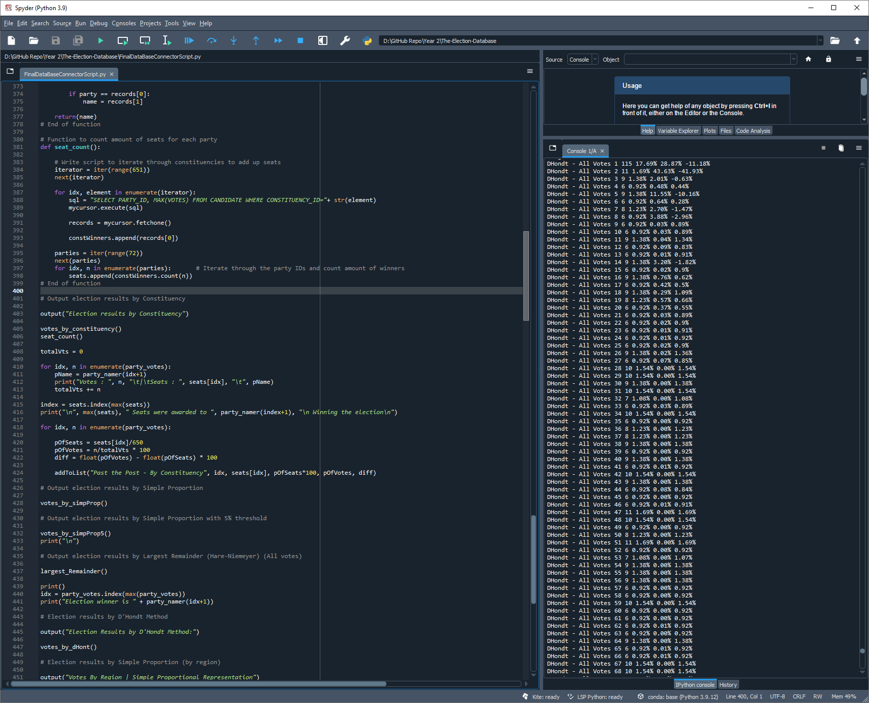One of the first tasks was to implement a method of capturing and storing data. For the first question, I pulled the results using a select query, identifying the candidate with the highest number of votes for each constituency. I created a ‘for’ loop to iterate through each returned result and accumulated all of the votes to calculate the total number of votes across all parties. This meant each seat could be allocated by adding one seat to each party that won the highest votes in each constituency. This was achieved by appending the seat count to a list where the total seats were inserted into the index of the ‘PARTY_ID’. (fig. 1)

Figure

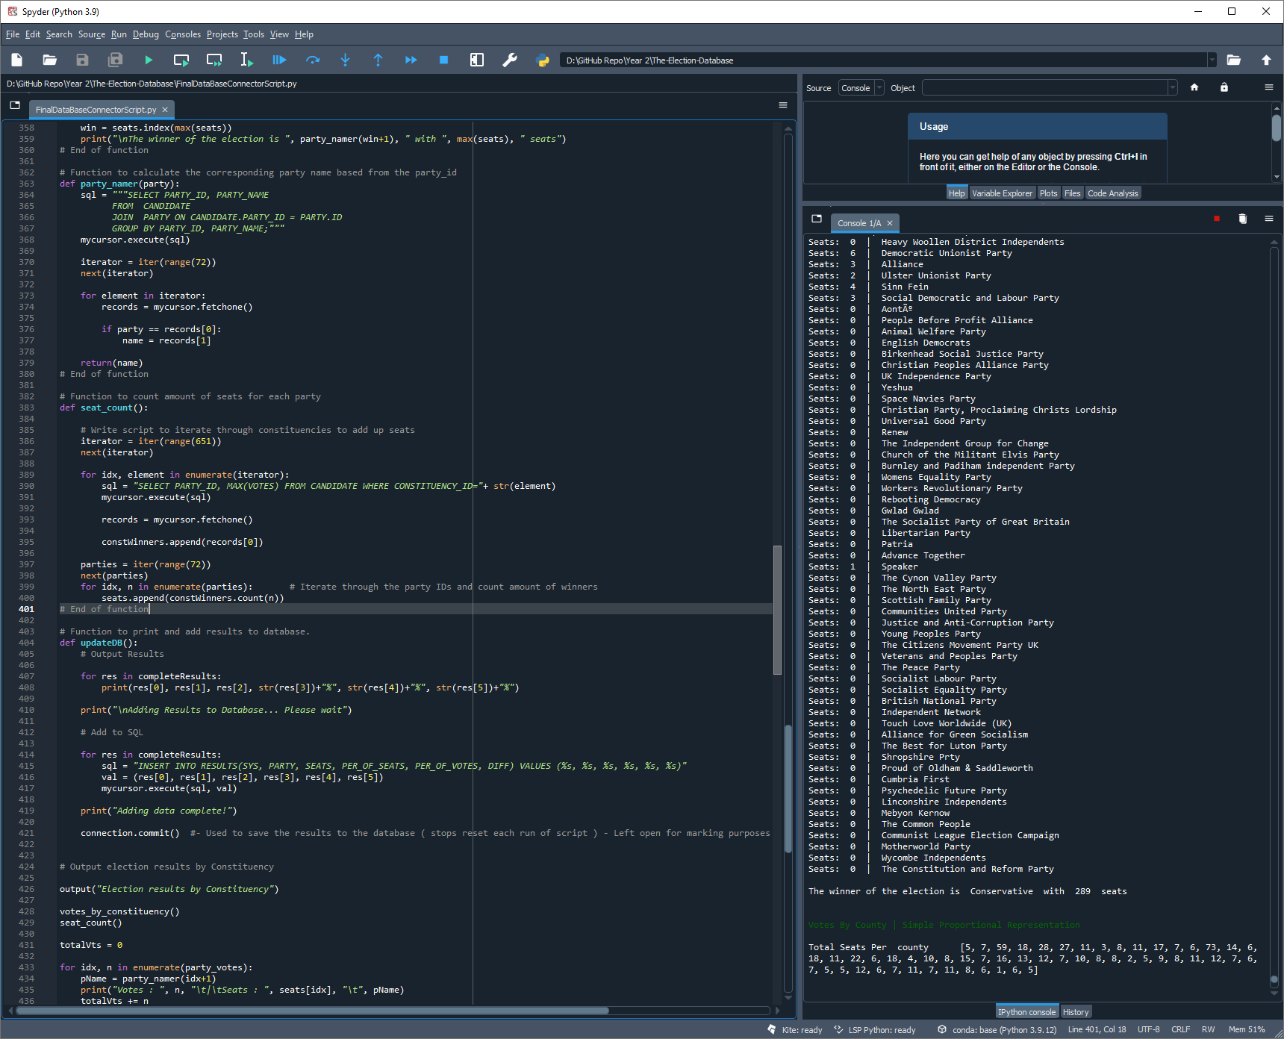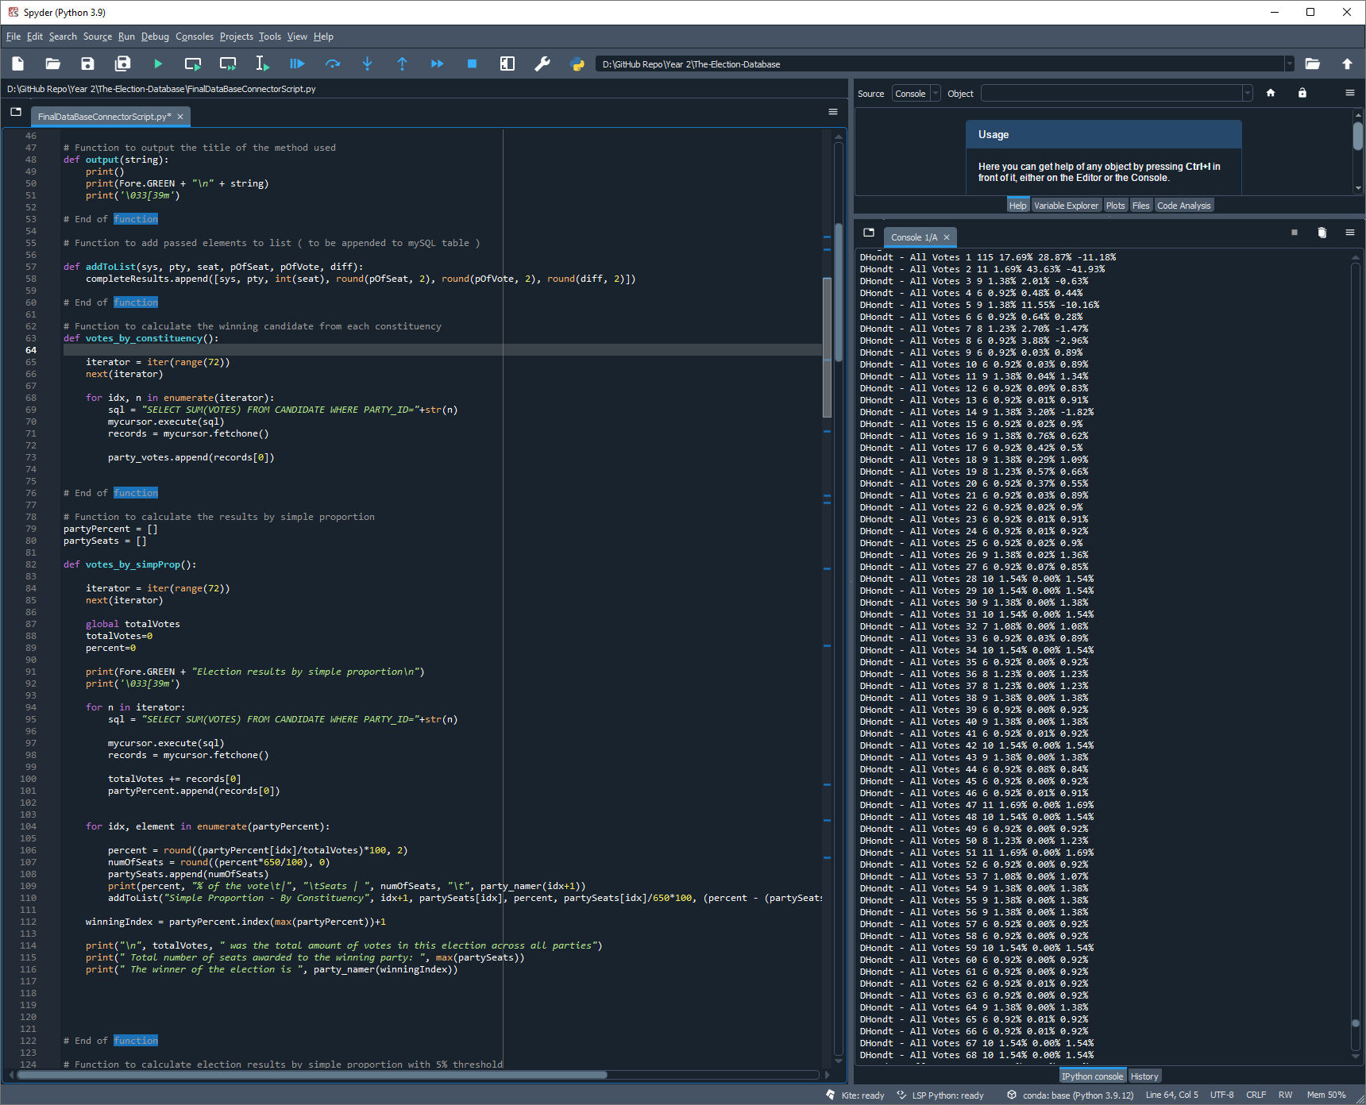The next step was to append the final results to a list which could later be added to a results table in the MySQL database. This was achieved using a function (fig. 2) which takes the values as arguments and appends these to a list. This list is later inserted into the table using a for loop which iterates through the list and uses ‘INSERT’ statements to add the data (fig. 3).

Figure

Figure

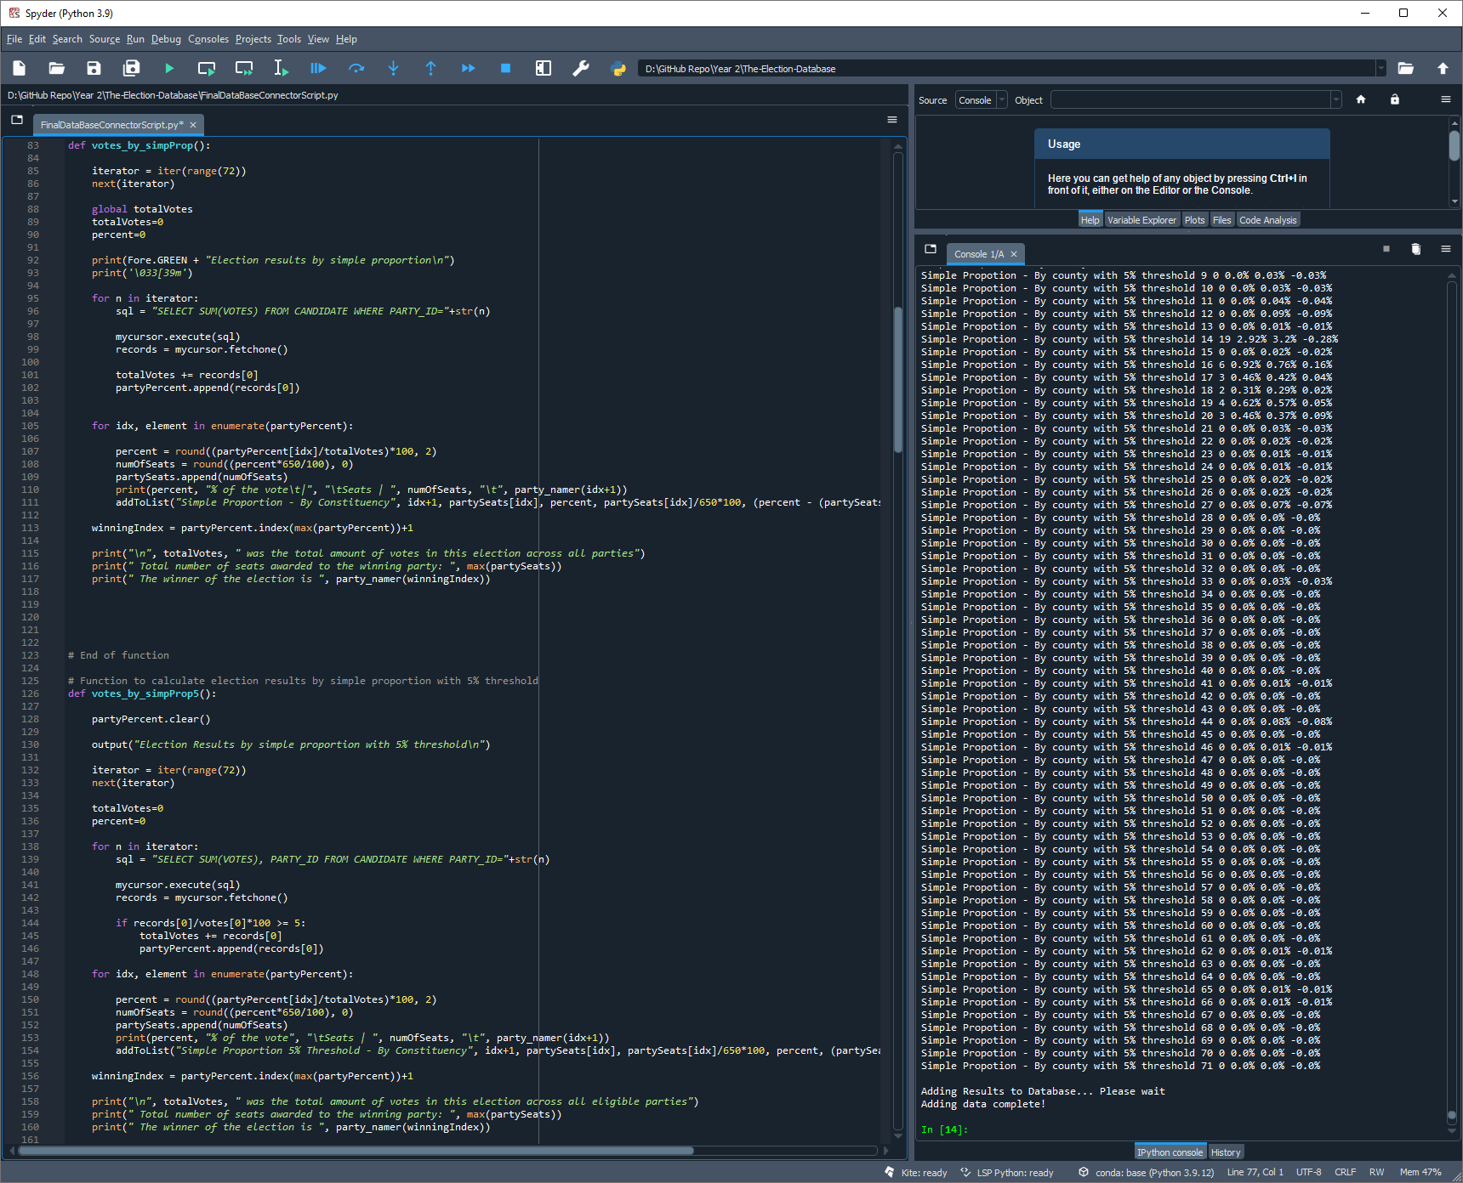Other voting methods such as ‘Simple Proportional Representation’ ‘Largest Remainder’ and ‘D’Hondt (Hare-Quota)’ used separate methods for each system since the calculations of seats differed between systems. The ‘Simple Proportional Representation’ method for example calculates the seats based on the percentages for each party. For this method, I used a function for the standard calculation and a separate function to remove the threshold from the votes and re-calculate percentages (fig. 4)

Figure

These functions are used to calculate the results by allocating a percentage for each party which is achieved by dividing the party’s total votes by the total votes for all parties. This is then rounded to show the percentage accurate to 2 decimal places and seats are rounded down to only allow whole seat numbers.

When calculating the parties with less than 5% of the vote, the function (votes_by_simpProp5) checks all of the percentages for each party within a ‘for’ loop which removes the votes that accumulate more than 5% of the total votes and add that party’s votes to the total votes across all parties. Once these results are added to the total votes (across all parties) the parties that are above the threshold are appended to a new list (partyPercent). This means only the valid parties are allocated seats and the percentages can be recalculated.

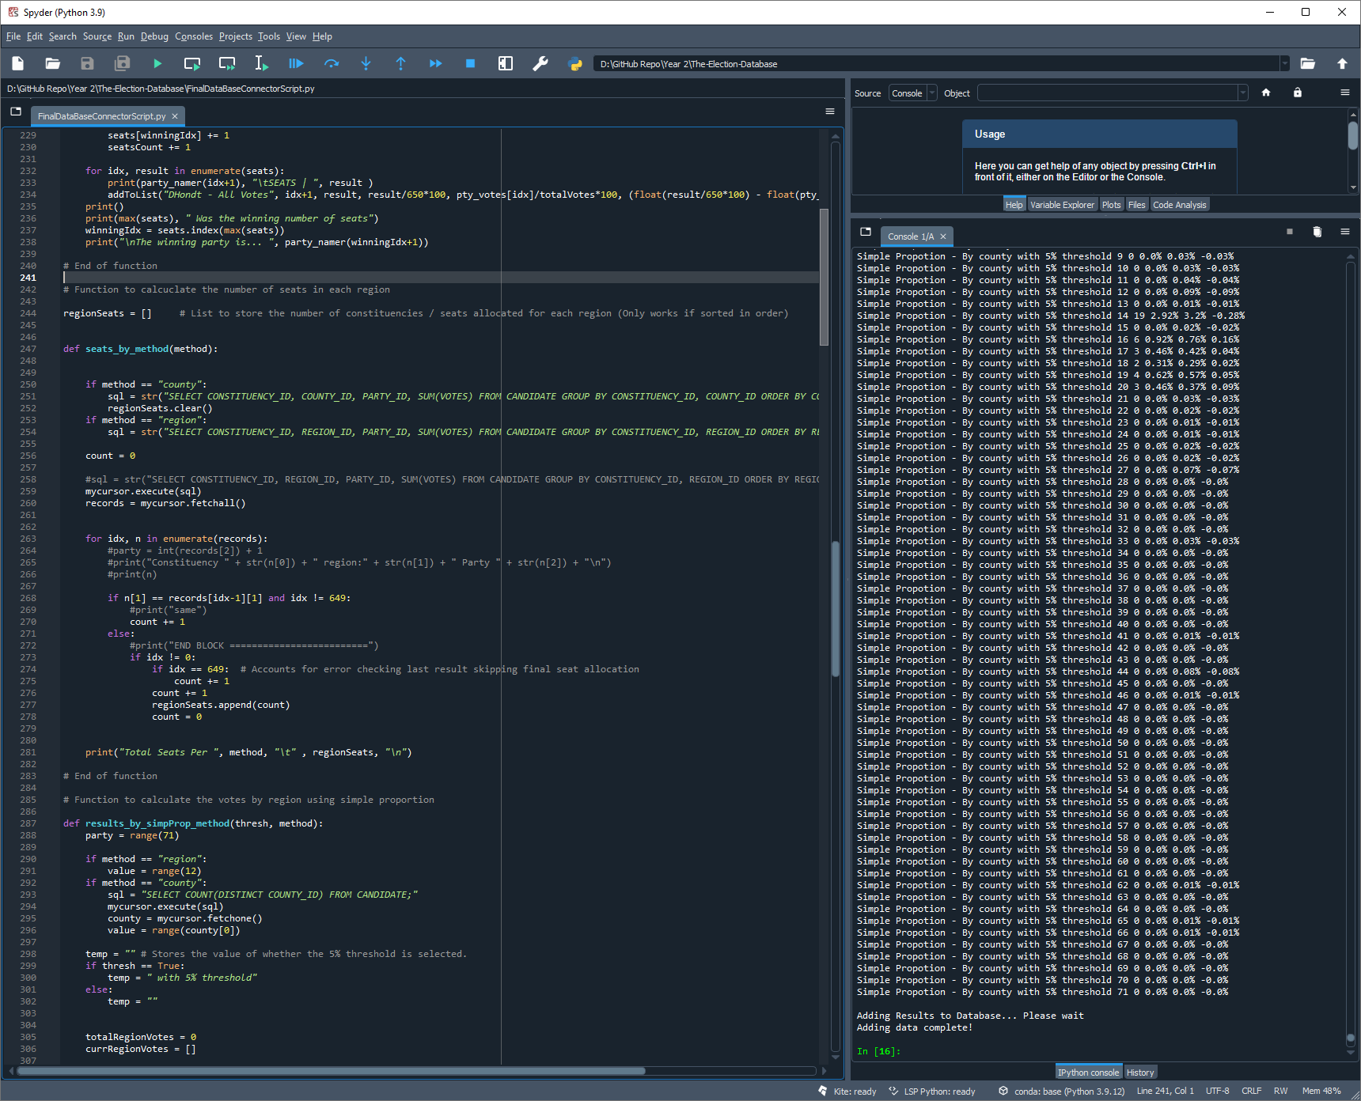Another major function that answers 1, 2, 3 and 4 in the advanced questions is the ‘results_by_simpProp_method()’ function (fig. 7). Multiple queries are calculated by passing the method (by region or by county) to the function, along with a Boolean value which defines whether the 5% threshold needs to be removed (True or False). Before this function is called, ‘seats_by_method()’ is called, this function allocates the total number of seats to a list, the total number of seats are calculated by passing the method into the function (etc. region or county).

Figure

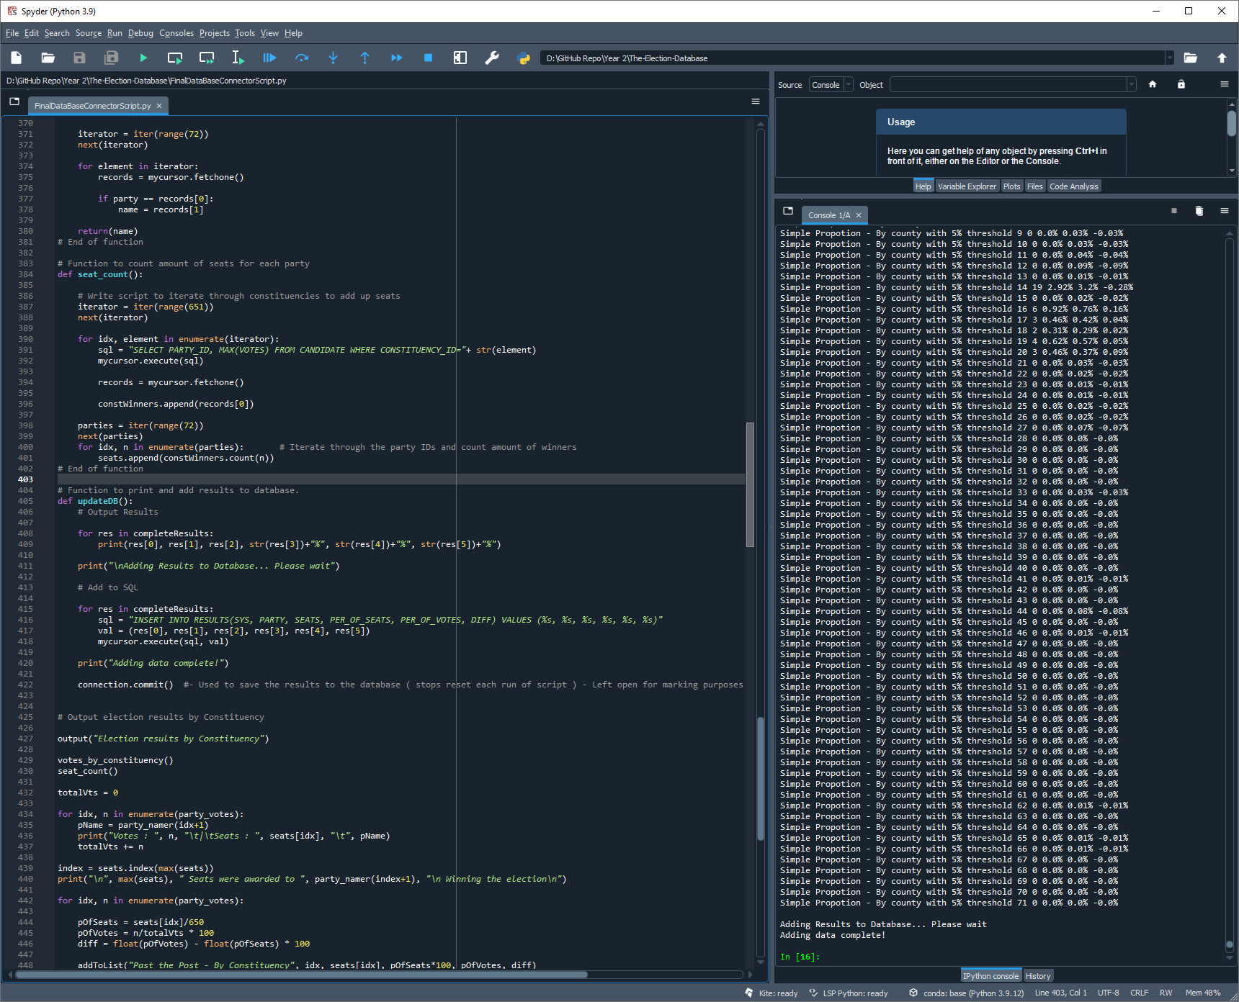The function (fig. 5) then runs the query depending on the method passed and returns the results using a cursor which calculates the number of seats per region or county (whichever specified). This was the more efficient solution replacing another function used to allocate the seats exclusively for that election method. (fig. 6)

Figure

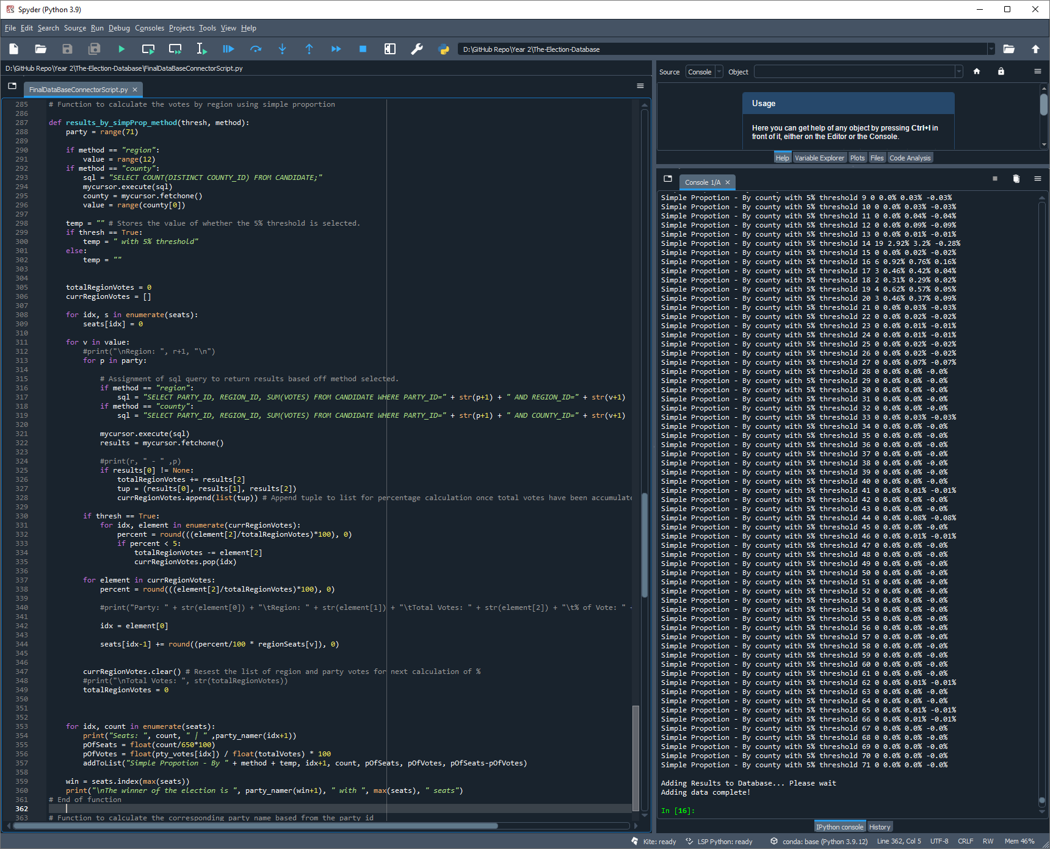To calculate the results for the specified questions (1, 2, 3 ,4 advanced). I created the ‘results_by_simpProp_method()’ function (fig. 7) where when called, runs a query depicted by the passed values. These values are used to calculate the seats, percentages of votes, percentage of seats and percentage difference of the votes and seats. Once the query is decided and executed, a for loop resets the seats list (since it was used previously and already contains values), and allocates seats by reading the results line-by-line and adding the total votes per region/county to a separate list.

Figure

The function then checks if the threshold is included and removes the results that don’t fit the criteria if excluded. Once this is complete, the current region/county votes are then iterated through once more to calculate the percentage of votes for each party within a region/county. Following this, the seats are allocated based from the total amount of seats for each region/county, this is achieved by multiplying the seats percentage by the total amount of seats available for the current region/county. These seats are then added to the list and the current region/county votes are reset, ready to read the results for the next region/county.

Once the list is cleared, the process iterates until all of the regions/counties have been accounted for and the results are appended to the ‘completeResults’ list. This stores all of the calculated results that need to be added to the MySQL database table storing the results.

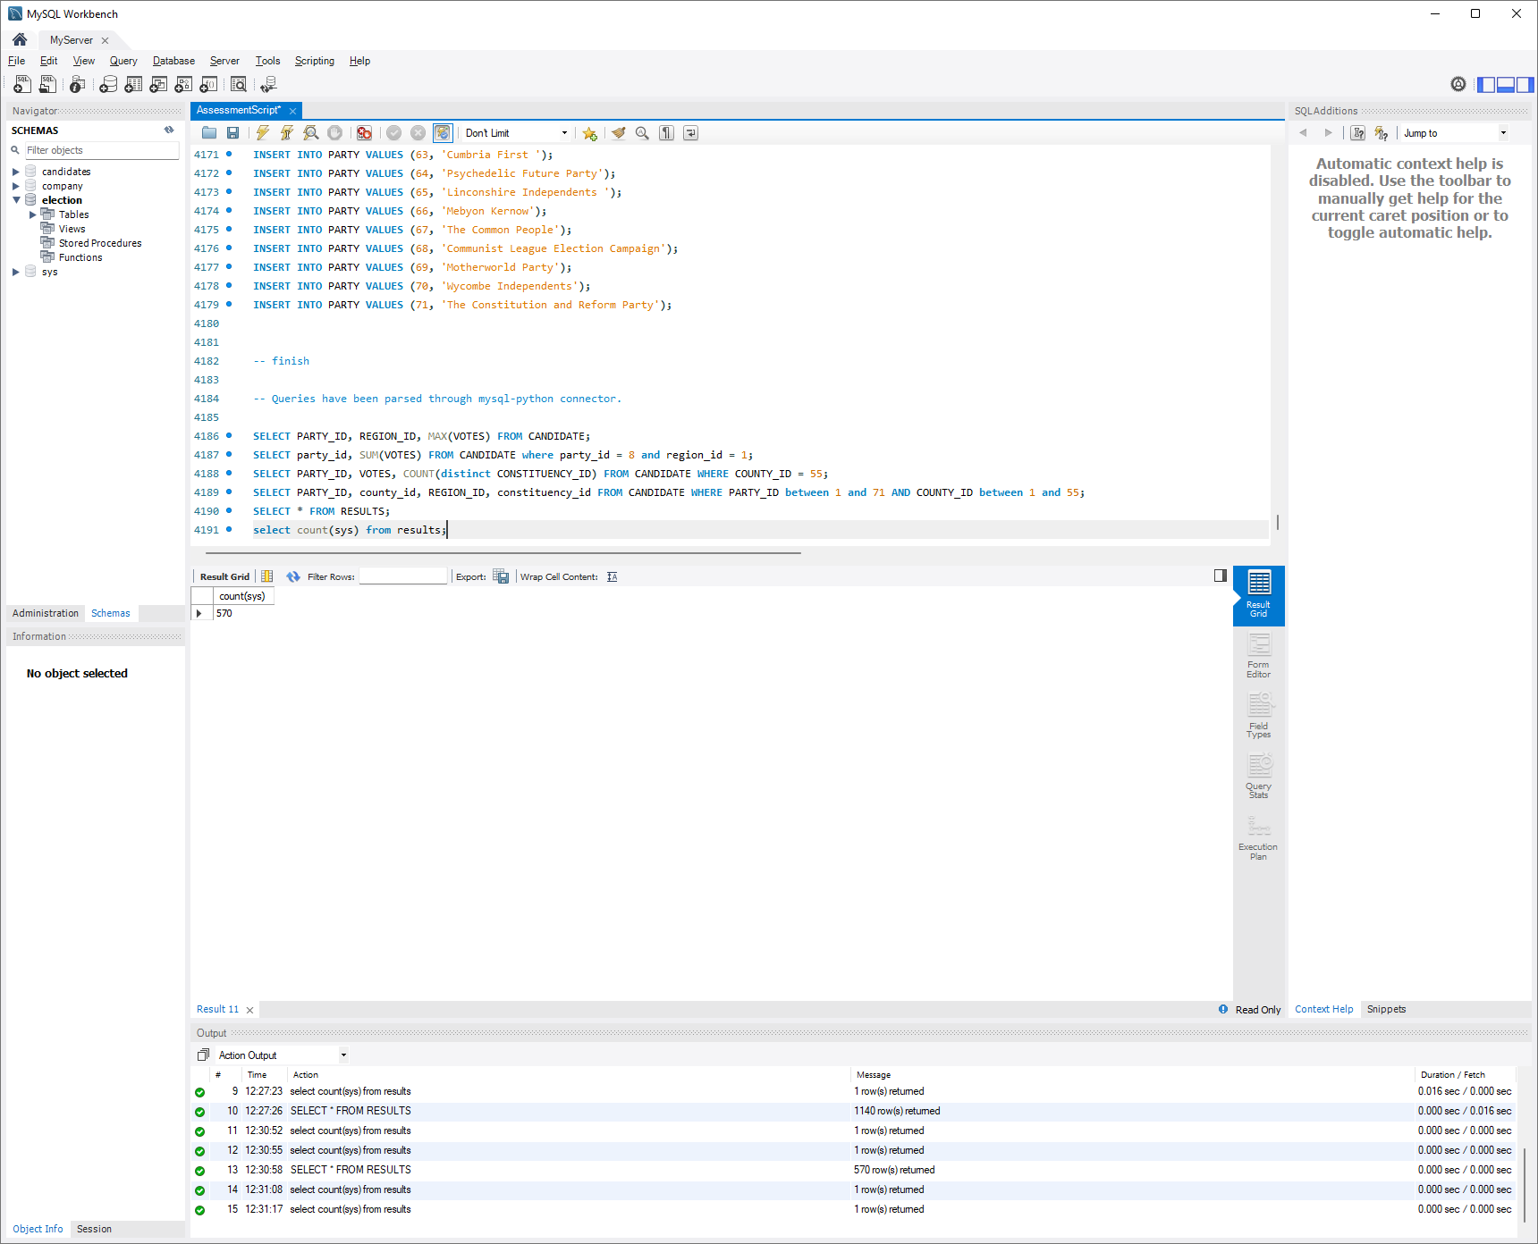To test the correct results are returned for each question/function, I ran select queries in the MySQL Workbench tool to check the results and confirm the correct data is returned. These can be seen in figure 8. (fig. 8)

Figure

As previously mentioned, the data was added to the SQL server by using insert statements and defining tables with the appropriate data types. The tables and insert statement examples can be seen (fig. 9 & 10)

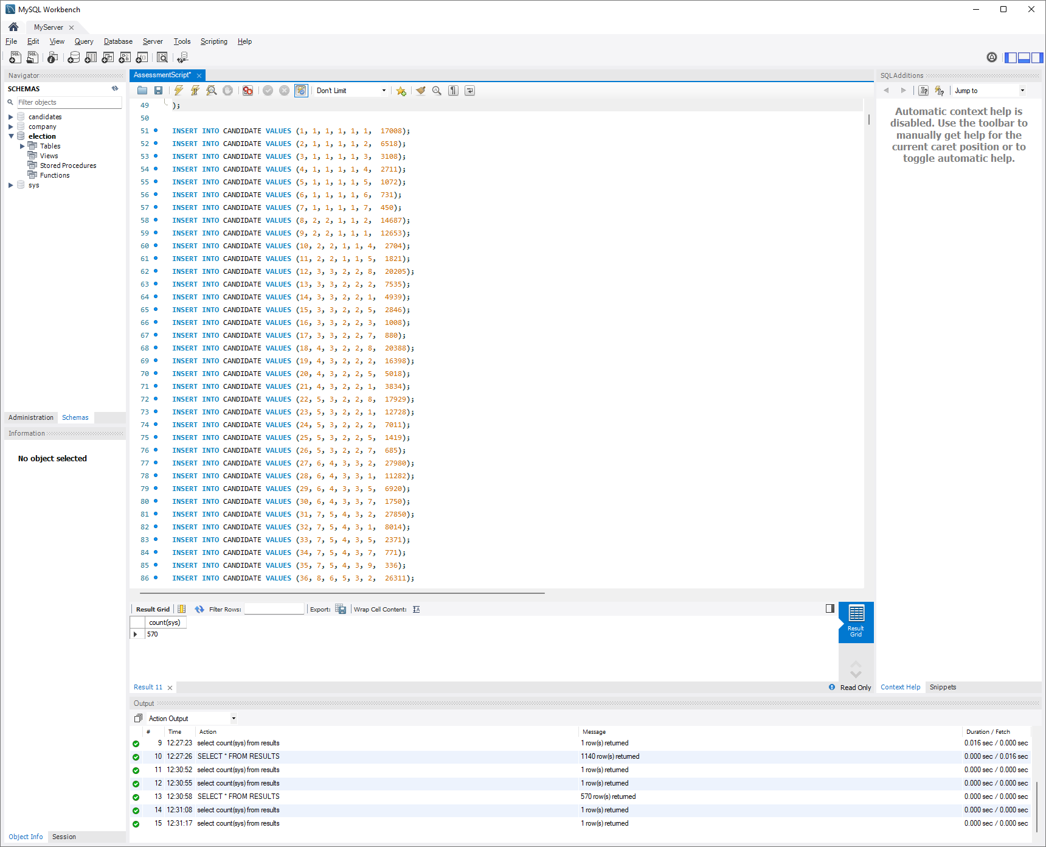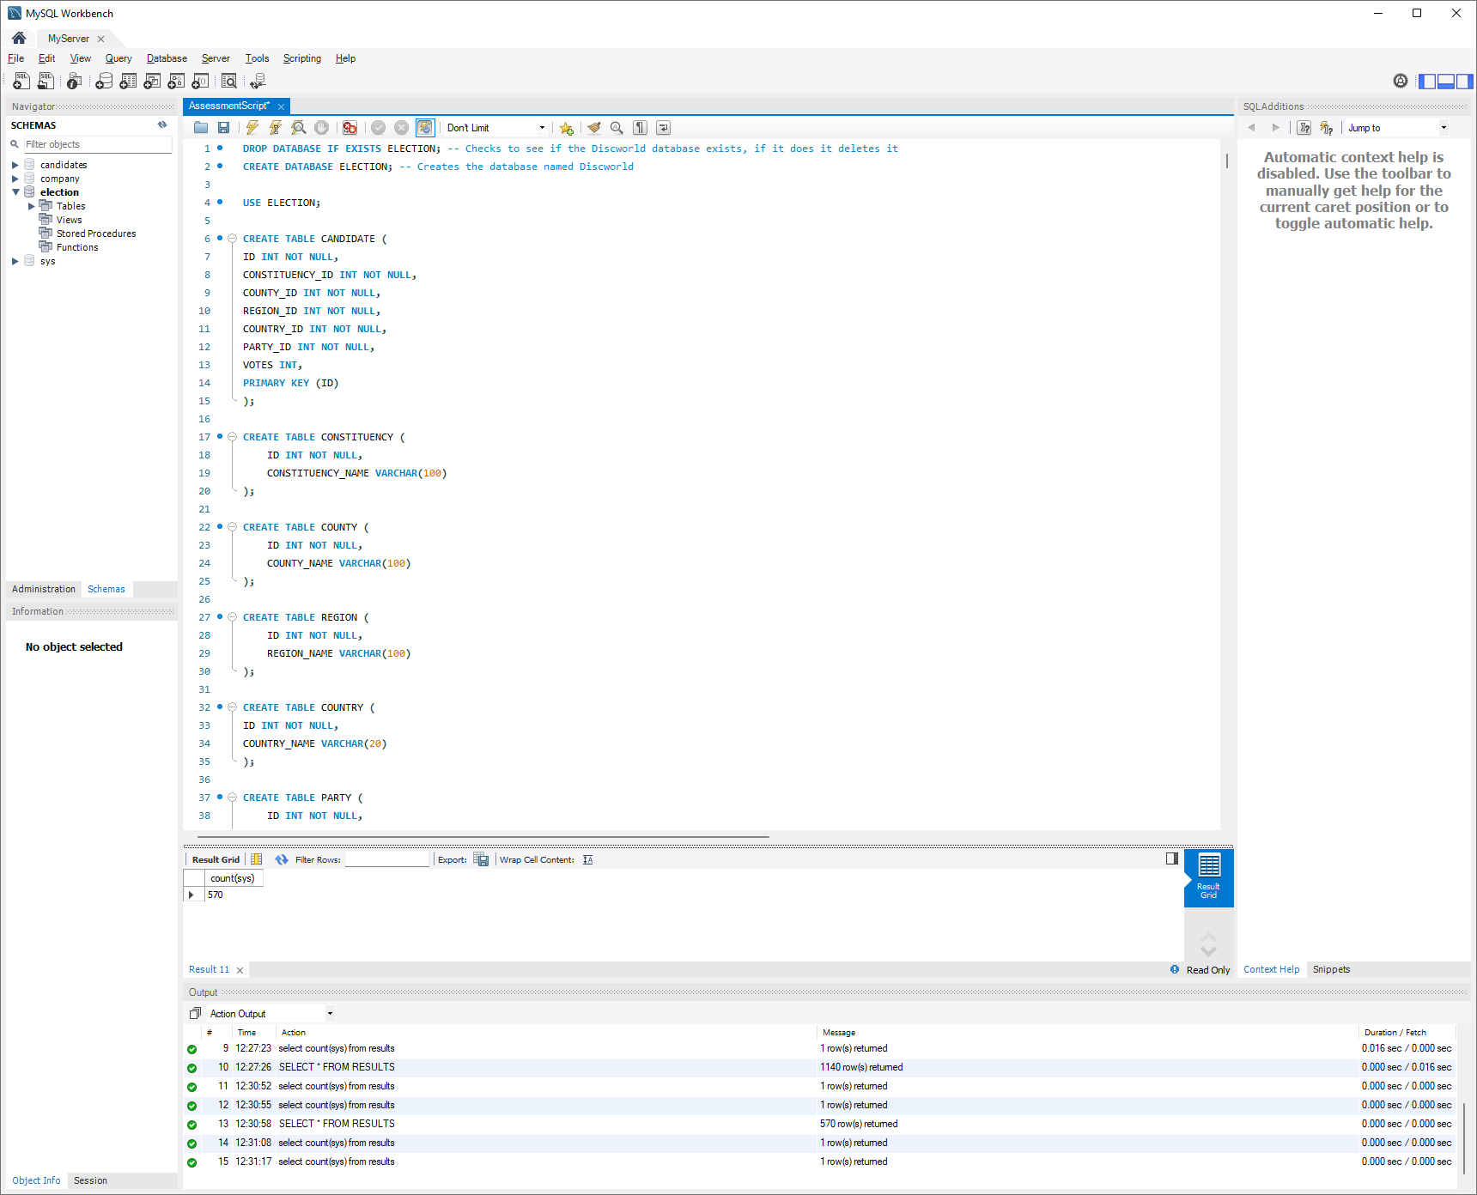

Figure

Figure

# Critical Reflection:

I think the MySQL database was successful since I added all of the normalised data removing all non-essential elements (country & candidate names etc). The data types and character limits set were all appropriate for the data being stored and didn’t need changing when inserting data.

Each unique value had a primary key and other duplicate data used foreign keys and junction tables which performed well within the python scripts when performing joins to lookup names. I wanted to keep the SQL scripts minimal and only execute queries in python after being tested in SQL workbench. This meant that the scripts were easier to read since all of the queries and results are located within the same script. This reduced time when debugging preventing the need to flick between systems to locate the error.

Using python, I did find that after completing some questions using a function per question, resulted in duplicate code / querying data. This meant that for some of the advanced questions, I could reduce duplicate code by storing common values in global lists/variables etc. This meant that I could calculate seats per region/county within the same function and pass parameters to the master function in order to specify how the data is manipulated.

I didn’t have time to replace the existing distinct functions with a master function, this could have helped to reduce a lot of duplicate code and minimalize the complexity of the script. I could also have reduced duplicate code by cloning the list of results used across various questions, this would mean the results wouldn’t have to be reset for each question after modifying the values for several different methods. A cloned list would ensure the initial results wouldn’t be modified globally.

Security:

The web front end was not implemented as advised, the security of the database is little since the database only runs on a local server, disconnected from access remotely. This means that the database cannot be accessed externally however, if this wasn’t hosted on a small home network, anyone on the local area network could access, modify and remove any data on the database if they gained access to the root password. The python script also stores the password in a string which could lessen the security of the database if someone gained access to the script file.

# Testing:

|  |  |  |  |  |  |  |  |
| --- | --- | --- | --- | --- | --- | --- | --- |
| ID | Test Description | Test Data | Expected Result | Outputted Result | Pass/Fail | Rectified (Y/N) | Fix Applied |
| 1 | Decimal values added to the results list are accurate to 2 decimal places | ‘First Past the Post’, 1, 10, 20.23151513, 20.4955862, 20.23151513-20.4955862 | ‘First Past the Post’, 1, 10, 20.23, 20.50, -0.27 | ‘First Past the Post’, 1, 10, 20.23, 20.50, -0.27 | PASS | N | N/A |
| 2 | Seat values are displayed as integers | Seats = 7.0 | Seats = 7 | 7.0 | FAIL | Partially | When outputted into console some results still show as decimals |
| 3 | Calculate Percentages for seats / Votes | Seats/650*100  Votes/totalVotes*100 | Correct seat percentages | TypeError: unsupported operand type(s) for -: 'decimal.Decimal' and 'float' | FAIL | Y | Program now runs as expected, added float() function to both values since data-types were different |
| 4 | Check if results have calculated correctly before adding to MySQL | Print(results)  Conservative = 44% of votes | 44% votes | All results showing < 1%  Result = 0.44% | FAIL | Y | Multiplied result by 100 before performing calculations. |
| 5 | Outputting party name for each party ID | Party_namer(1) | Conservative party | Labour | FAIL | Y | Add one to the value passed into the function since the value passed is the index of the list which starts at 0 not 1. |

# Electoral Analysis:

The Simple Proportional Representation and First Past the Post methods returned similar results still with the majority votes translating to majority seats. This did mean that smaller parties had little chance of having seats allocated and lesser reflects the total amount of votes for the smaller parties.

Implementing a threshold however, eliminates all of the parties with few votes and provides more seats to the majority vote parties. This meant that parties with few votes wouldn’t be allocated a seat and the majority parties were provided with all of the seats which could reflect the publics vote in a more appropriate way.

Methods such as D’Hondt and Largest Remainder allocated more seats for the minority parties and allowed parties with fewer votes to gain seats that reflect the number of people that voted for the party instead of allocating seats based on the majority vote by area (region/county/constituency). Seats were allocated more evenly across all parties using these methods.

Further, the D’Hondt method interestingly allocated more seats to the Labour party, the majority votes were often discarded, leaving the conservative party with very few seats in proportion to the winning party.

# Results:

The results are displayed as suggested:

**System Name, Party ID, Number of Seats, % of Seats, % of Votes, % difference**

|  |  |  |  |  |  |
| --- | --- | --- | --- | --- | --- |
| Past the Post - By Constituency | 0 | 176 | 27.08 | 28.87 | 1.8 |
| Past the Post - By Constituency | 1 | 365 | 56.15 | 43.63 | -12.53 |
| Past the Post - By Constituency | 2 | 0 | 0 | 2.01 | 2.01 |
| Past the Post - By Constituency | 3 | 4 | 0.62 | 0.48 | -0.14 |
| Past the Post - By Constituency | 4 | 11 | 1.69 | 11.55 | 9.85 |
| Past the Post - By Constituency | 5 | 0 | 0 | 0.64 | 0.64 |
| Past the Post - By Constituency | 6 | 1 | 0.15 | 2.7 | 2.55 |
| Past the Post - By Constituency | 7 | 48 | 7.38 | 3.88 | -3.5 |
| Past the Post - By Constituency | 8 | 0 | 0 | 0.03 | 0.03 |
| Past the Post - By Constituency | 9 | 0 | 0 | 0.03 | 0.03 |
| Past the Post - By Constituency | 10 | 0 | 0 | 0.04 | 0.04 |
| Past the Post - By Constituency | 11 | 0 | 0 | 0.09 | 0.09 |
| Past the Post - By Constituency | 12 | 0 | 0 | 0.01 | 0.01 |
| Past the Post - By Constituency | 13 | 26 | 4 | 3.2 | -0.8 |
| Past the Post - By Constituency | 14 | 0 | 0 | 0.02 | 0.02 |
| Past the Post - By Constituency | 15 | 8 | 1.23 | 0.76 | -0.47 |
| Past the Post - By Constituency | 16 | 1 | 0.15 | 0.42 | 0.27 |
| Past the Post - By Constituency | 17 | 0 | 0 | 0.29 | 0.29 |
| Past the Post - By Constituency | 18 | 7 | 1.08 | 0.57 | -0.51 |
| Past the Post - By Constituency | 19 | 2 | 0.31 | 0.37 | 0.06 |
| Past the Post - By Constituency | 20 | 0 | 0 | 0.03 | 0.03 |
| Past the Post - By Constituency | 21 | 0 | 0 | 0.02 | 0.02 |
| Past the Post - By Constituency | 22 | 0 | 0 | 0.01 | 0.01 |
| Past the Post - By Constituency | 23 | 0 | 0 | 0.01 | 0.01 |
| Past the Post - By Constituency | 24 | 0 | 0 | 0.02 | 0.02 |
| Past the Post - By Constituency | 25 | 0 | 0 | 0.02 | 0.02 |
| Past the Post - By Constituency | 26 | 0 | 0 | 0.07 | 0.07 |
| Past the Post - By Constituency | 27 | 0 | 0 | 0 | 0 |
| Past the Post - By Constituency | 28 | 0 | 0 | 0 | 0 |
| Past the Post - By Constituency | 29 | 0 | 0 | 0 | 0 |
| Past the Post - By Constituency | 30 | 0 | 0 | 0 | 0 |
| Past the Post - By Constituency | 31 | 0 | 0 | 0 | 0 |
| Past the Post - By Constituency | 32 | 0 | 0 | 0.03 | 0.03 |
| Past the Post - By Constituency | 33 | 0 | 0 | 0 | 0 |
| Past the Post - By Constituency | 34 | 0 | 0 | 0 | 0 |
| Past the Post - By Constituency | 35 | 0 | 0 | 0 | 0 |
| Past the Post - By Constituency | 36 | 0 | 0 | 0 | 0 |
| Past the Post - By Constituency | 37 | 0 | 0 | 0 | 0 |
| Past the Post - By Constituency | 38 | 0 | 0 | 0 | 0 |
| Past the Post - By Constituency | 39 | 0 | 0 | 0 | 0 |
| Past the Post - By Constituency | 40 | 0 | 0 | 0.01 | 0.01 |
| Past the Post - By Constituency | 41 | 0 | 0 | 0 | 0 |
| Past the Post - By Constituency | 42 | 0 | 0 | 0 | 0 |
| Past the Post - By Constituency | 43 | 1 | 0.15 | 0.08 | -0.07 |
| Past the Post - By Constituency | 44 | 0 | 0 | 0 | 0 |
| Past the Post - By Constituency | 45 | 0 | 0 | 0.01 | 0.01 |
| Past the Post - By Constituency | 46 | 0 | 0 | 0 | 0 |
| Past the Post - By Constituency | 47 | 0 | 0 | 0 | 0 |
| Past the Post - By Constituency | 48 | 0 | 0 | 0 | 0 |
| Past the Post - By Constituency | 49 | 0 | 0 | 0 | 0 |
| Past the Post - By Constituency | 50 | 0 | 0 | 0 | 0 |
| Past the Post - By Constituency | 51 | 0 | 0 | 0 | 0 |
| Past the Post - By Constituency | 52 | 0 | 0 | 0 | 0 |
| Past the Post - By Constituency | 53 | 0 | 0 | 0 | 0 |
| Past the Post - By Constituency | 54 | 0 | 0 | 0 | 0 |
| Past the Post - By Constituency | 55 | 0 | 0 | 0 | 0 |
| Past the Post - By Constituency | 56 | 0 | 0 | 0 | 0 |
| Past the Post - By Constituency | 57 | 0 | 0 | 0 | 0 |
| Past the Post - By Constituency | 58 | 0 | 0 | 0 | 0 |
| Past the Post - By Constituency | 59 | 0 | 0 | 0 | 0 |
| Past the Post - By Constituency | 60 | 0 | 0 | 0 | 0 |
| Past the Post - By Constituency | 61 | 0 | 0 | 0.01 | 0.01 |
| Past the Post - By Constituency | 62 | 0 | 0 | 0 | 0 |
| Past the Post - By Constituency | 63 | 0 | 0 | 0 | 0 |
| Past the Post - By Constituency | 64 | 0 | 0 | 0.01 | 0.01 |
| Past the Post - By Constituency | 65 | 0 | 0 | 0.01 | 0.01 |
| Past the Post - By Constituency | 66 | 0 | 0 | 0 | 0 |
| Past the Post - By Constituency | 67 | 0 | 0 | 0 | 0 |
| Past the Post - By Constituency | 68 | 0 | 0 | 0 | 0 |
| Past the Post - By Constituency | 69 | 0 | 0 | 0 | 0 |
| Past the Post - By Constituency | 70 | 0 | 0 | 0 | 0 |
| Simple Proportional Representation - By Constituency | 1 | 188 | 28.87 | 28.92 | -0.05 |
| Simple Proportional Representation - By Constituency | 2 | 284 | 43.63 | 43.69 | -0.06 |
| Simple Proportional Representation - By Constituency | 3 | 13 | 2.01 | 2 | 0.01 |
| Simple Proportional Representation - By Constituency | 4 | 3 | 0.48 | 0.46 | 0.02 |
| Simple Proportional Representation - By Constituency | 5 | 75 | 11.55 | 11.54 | 0.01 |
| Simple Proportional Representation - By Constituency | 6 | 4 | 0.64 | 0.62 | 0.02 |
| Simple Proportional Representation - By Constituency | 7 | 18 | 2.7 | 2.77 | -0.07 |
| Simple Proportional Representation - By Constituency | 8 | 25 | 3.88 | 3.85 | 0.03 |
| Simple Proportional Representation - By Constituency | 9 | 0 | 0.03 | 0 | 0.03 |
| Simple Proportional Representation - By Constituency | 10 | 0 | 0.03 | 0 | 0.03 |
| Simple Proportional Representation - By Constituency | 11 | 0 | 0.04 | 0 | 0.04 |
| Simple Proportional Representation - By Constituency | 12 | 1 | 0.09 | 0.15 | -0.06 |
| Simple Proportional Representation - By Constituency | 13 | 0 | 0.01 | 0 | 0.01 |
| Simple Proportional Representation - By Constituency | 14 | 21 | 3.2 | 3.23 | -0.03 |
| Simple Proportional Representation - By Constituency | 15 | 0 | 0.02 | 0 | 0.02 |
| Simple Proportional Representation - By Constituency | 16 | 5 | 0.76 | 0.77 | -0.01 |
| Simple Proportional Representation - By Constituency | 17 | 3 | 0.42 | 0.46 | -0.04 |
| Simple Proportional Representation - By Constituency | 18 | 2 | 0.29 | 0.31 | -0.02 |
| Simple Proportional Representation - By Constituency | 19 | 4 | 0.57 | 0.62 | -0.05 |
| Simple Proportional Representation - By Constituency | 20 | 2 | 0.37 | 0.31 | 0.06 |
| Simple Proportional Representation - By Constituency | 21 | 0 | 0.03 | 0 | 0.03 |
| Simple Proportional Representation - By Constituency | 22 | 0 | 0.02 | 0 | 0.02 |
| Simple Proportional Representation - By Constituency | 23 | 0 | 0.01 | 0 | 0.01 |
| Simple Proportional Representation - By Constituency | 24 | 0 | 0.01 | 0 | 0.01 |
| Simple Proportional Representation - By Constituency | 25 | 0 | 0.02 | 0 | 0.02 |
| Simple Proportional Representation - By Constituency | 26 | 0 | 0.02 | 0 | 0.02 |
| Simple Proportional Representation - By Constituency | 27 | 0 | 0.07 | 0 | 0.07 |
| Simple Proportional Representation - By Constituency | 28 | 0 | 0 | 0 | 0 |
| Simple Proportional Representation - By Constituency | 29 | 0 | 0 | 0 | 0 |
| Simple Proportional Representation - By Constituency | 30 | 0 | 0 | 0 | 0 |
| Simple Proportional Representation - By Constituency | 31 | 0 | 0 | 0 | 0 |
| Simple Proportional Representation - By Constituency | 32 | 0 | 0 | 0 | 0 |
| Simple Proportional Representation - By Constituency | 33 | 0 | 0.03 | 0 | 0.03 |
| Simple Proportional Representation - By Constituency | 34 | 0 | 0 | 0 | 0 |
| Simple Proportional Representation - By Constituency | 35 | 0 | 0 | 0 | 0 |
| Simple Proportional Representation - By Constituency | 36 | 0 | 0 | 0 | 0 |
| Simple Proportional Representation - By Constituency | 37 | 0 | 0 | 0 | 0 |
| Simple Proportional Representation - By Constituency | 38 | 0 | 0 | 0 | 0 |
| Simple Proportional Representation - By Constituency | 39 | 0 | 0 | 0 | 0 |
| Simple Proportional Representation - By Constituency | 40 | 0 | 0 | 0 | 0 |
| Simple Proportional Representation - By Constituency | 41 | 0 | 0.01 | 0 | 0.01 |
| Simple Proportional Representation - By Constituency | 42 | 0 | 0 | 0 | 0 |
| Simple Proportional Representation - By Constituency | 43 | 0 | 0 | 0 | 0 |
| Simple Proportional Representation - By Constituency | 44 | 1 | 0.08 | 0.15 | -0.07 |
| Simple Proportional Representation - By Constituency | 45 | 0 | 0 | 0 | 0 |
| Simple Proportional Representation - By Constituency | 46 | 0 | 0.01 | 0 | 0.01 |
| Simple Proportional Representation - By Constituency | 47 | 0 | 0 | 0 | 0 |
| Simple Proportional Representation - By Constituency | 48 | 0 | 0 | 0 | 0 |
| Simple Proportional Representation - By Constituency | 49 | 0 | 0 | 0 | 0 |
| Simple Proportional Representation - By Constituency | 50 | 0 | 0 | 0 | 0 |
| Simple Proportional Representation - By Constituency | 51 | 0 | 0 | 0 | 0 |
| Simple Proportional Representation - By Constituency | 52 | 0 | 0 | 0 | 0 |
| Simple Proportional Representation - By Constituency | 53 | 0 | 0 | 0 | 0 |
| Simple Proportional Representation - By Constituency | 54 | 0 | 0 | 0 | 0 |
| Simple Proportional Representation - By Constituency | 55 | 0 | 0 | 0 | 0 |
| Simple Proportional Representation - By Constituency | 56 | 0 | 0 | 0 | 0 |
| Simple Proportional Representation - By Constituency | 57 | 0 | 0 | 0 | 0 |
| Simple Proportional Representation - By Constituency | 58 | 0 | 0 | 0 | 0 |
| Simple Proportional Representation - By Constituency | 59 | 0 | 0 | 0 | 0 |
| Simple Proportional Representation - By Constituency | 60 | 0 | 0 | 0 | 0 |
| Simple Proportional Representation - By Constituency | 61 | 0 | 0 | 0 | 0 |
| Simple Proportional Representation - By Constituency | 62 | 0 | 0.01 | 0 | 0.01 |
| Simple Proportional Representation - By Constituency | 63 | 0 | 0 | 0 | 0 |
| Simple Proportional Representation - By Constituency | 64 | 0 | 0 | 0 | 0 |
| Simple Proportional Representation - By Constituency | 65 | 0 | 0.01 | 0 | 0.01 |
| Simple Proportional Representation - By Constituency | 66 | 0 | 0.01 | 0 | 0.01 |
| Simple Proportional Representation - By Constituency | 67 | 0 | 0 | 0 | 0 |
| Simple Proportional Representation - By Constituency | 68 | 0 | 0 | 0 | 0 |
| Simple Proportional Representation - By Constituency | 69 | 0 | 0 | 0 | 0 |
| Simple Proportional Representation - By Constituency | 70 | 0 | 0 | 0 | 0 |
| Simple Proportional Representation - By Constituency | 71 | 0 | 0 | 0 | 0 |
| Simple Proportional Representation 5% Threshold - By Constituency | 1 | 188 | 28.92 | 34.35 | -5.43 |
| Simple Proportional Representation 5% Threshold - By Constituency | 2 | 284 | 43.69 | 51.91 | -8.22 |
| Simple Proportional Representation 5% Threshold - By Constituency | 3 | 13 | 2 | 13.74 | -11.74 |
| Largest Remainder - All Votes | 1 | 188 | 28.92 | 28.87 | 27.51 |
| Largest Remainder - All Votes | 2 | 284 | 43.69 | 43.63 | 41.56 |
| Largest Remainder - All Votes | 3 | 13 | 2 | 2.01 | 1.9 |
| Largest Remainder - All Votes | 4 | 3 | 0.46 | 0.48 | 0.44 |
| Largest Remainder - All Votes | 5 | 75 | 11.54 | 11.55 | 10.98 |
| Largest Remainder - All Votes | 6 | 4 | 0.62 | 0.64 | 0.58 |
| Largest Remainder - All Votes | 7 | 18 | 2.77 | 2.7 | 2.64 |
| Largest Remainder - All Votes | 8 | 25 | 3.85 | 3.88 | 3.66 |
| Largest Remainder - All Votes | 9 | 0 | 0 | 0.03 | -0 |
| Largest Remainder - All Votes | 10 | 0 | 0 | 0.03 | -0 |
| Largest Remainder - All Votes | 11 | 0 | 0 | 0.04 | -0 |
| Largest Remainder - All Votes | 12 | 1 | 0.15 | 0.09 | 0.15 |
| Largest Remainder - All Votes | 13 | 0 | 0 | 0.01 | -0 |
| Largest Remainder - All Votes | 14 | 21 | 3.23 | 3.2 | 3.07 |
| Largest Remainder - All Votes | 15 | 0 | 0 | 0.02 | -0 |
| Largest Remainder - All Votes | 16 | 5 | 0.77 | 0.76 | 0.73 |
| Largest Remainder - All Votes | 17 | 3 | 0.46 | 0.42 | 0.44 |
| Largest Remainder - All Votes | 18 | 2 | 0.31 | 0.29 | 0.29 |
| Largest Remainder - All Votes | 19 | 4 | 0.62 | 0.57 | 0.59 |
| Largest Remainder - All Votes | 20 | 2 | 0.31 | 0.37 | 0.29 |
| Largest Remainder - All Votes | 21 | 0 | 0 | 0.03 | -0 |
| Largest Remainder - All Votes | 22 | 0 | 0 | 0.02 | -0 |
| Largest Remainder - All Votes | 23 | 0 | 0 | 0.01 | -0 |
| Largest Remainder - All Votes | 24 | 0 | 0 | 0.01 | -0 |
| Largest Remainder - All Votes | 25 | 0 | 0 | 0.02 | -0 |
| Largest Remainder - All Votes | 26 | 0 | 0 | 0.02 | -0 |
| Largest Remainder - All Votes | 27 | 0 | 0 | 0.07 | -0 |
| Largest Remainder - All Votes | 28 | 0 | 0 | 0 | -0 |
| Largest Remainder - All Votes | 29 | 0 | 0 | 0 | -0 |
| Largest Remainder - All Votes | 30 | 0 | 0 | 0 | -0 |
| Largest Remainder - All Votes | 31 | 0 | 0 | 0 | -0 |
| Largest Remainder - All Votes | 32 | 0 | 0 | 0 | -0 |
| Largest Remainder - All Votes | 33 | 0 | 0 | 0.03 | -0 |
| Largest Remainder - All Votes | 34 | 0 | 0 | 0 | -0 |
| Largest Remainder - All Votes | 35 | 0 | 0 | 0 | -0 |
| Largest Remainder - All Votes | 36 | 0 | 0 | 0 | -0 |
| Largest Remainder - All Votes | 37 | 0 | 0 | 0 | -0 |
| Largest Remainder - All Votes | 38 | 0 | 0 | 0 | -0 |
| Largest Remainder - All Votes | 39 | 0 | 0 | 0 | -0 |
| Largest Remainder - All Votes | 40 | 0 | 0 | 0 | -0 |
| Largest Remainder - All Votes | 41 | 0 | 0 | 0.01 | -0 |
| Largest Remainder - All Votes | 42 | 0 | 0 | 0 | -0 |
| Largest Remainder - All Votes | 43 | 0 | 0 | 0 | -0 |
| Largest Remainder - All Votes | 44 | 1 | 0.15 | 0.08 | 0.15 |
| Largest Remainder - All Votes | 45 | 0 | 0 | 0 | -0 |
| Largest Remainder - All Votes | 46 | 0 | 0 | 0.01 | -0 |
| Largest Remainder - All Votes | 47 | 0 | 0 | 0 | -0 |
| Largest Remainder - All Votes | 48 | 0 | 0 | 0 | -0 |
| Largest Remainder - All Votes | 49 | 0 | 0 | 0 | -0 |
| Largest Remainder - All Votes | 50 | 0 | 0 | 0 | -0 |
| Largest Remainder - All Votes | 51 | 0 | 0 | 0 | -0 |
| Largest Remainder - All Votes | 52 | 0 | 0 | 0 | -0 |
| Largest Remainder - All Votes | 53 | 0 | 0 | 0 | -0 |
| Largest Remainder - All Votes | 54 | 0 | 0 | 0 | -0 |
| Largest Remainder - All Votes | 55 | 0 | 0 | 0 | -0 |
| Largest Remainder - All Votes | 56 | 0 | 0 | 0 | -0 |
| Largest Remainder - All Votes | 57 | 0 | 0 | 0 | -0 |
| Largest Remainder - All Votes | 58 | 0 | 0 | 0 | -0 |
| Largest Remainder - All Votes | 59 | 0 | 0 | 0 | -0 |
| Largest Remainder - All Votes | 60 | 0 | 0 | 0 | -0 |
| Largest Remainder - All Votes | 61 | 0 | 0 | 0 | -0 |
| Largest Remainder - All Votes | 62 | 0 | 0 | 0.01 | -0 |
| Largest Remainder - All Votes | 63 | 0 | 0 | 0 | -0 |
| Largest Remainder - All Votes | 64 | 0 | 0 | 0 | -0 |
| Largest Remainder - All Votes | 65 | 0 | 0 | 0.01 | -0 |
| Largest Remainder - All Votes | 66 | 0 | 0 | 0.01 | -0 |
| Largest Remainder - All Votes | 67 | 0 | 0 | 0 | -0 |
| Largest Remainder - All Votes | 68 | 0 | 0 | 0 | -0 |
| Largest Remainder - All Votes | 69 | 0 | 0 | 0 | -0 |
| Largest Remainder - All Votes | 70 | 0 | 0 | 0 | -0 |
| DHondt - All Votes | 1 | 115 | 17.69 | 28.87 | -11.18 |
| DHondt - All Votes | 2 | 11 | 1.69 | 43.63 | -41.93 |
| DHondt - All Votes | 3 | 9 | 1.38 | 2.01 | -0.63 |
| DHondt - All Votes | 4 | 6 | 0.92 | 0.48 | 0.44 |
| DHondt - All Votes | 5 | 9 | 1.38 | 11.55 | -10.16 |
| DHondt - All Votes | 6 | 6 | 0.92 | 0.64 | 0.28 |
| DHondt - All Votes | 7 | 8 | 1.23 | 2.7 | -1.47 |
| DHondt - All Votes | 8 | 6 | 0.92 | 3.88 | -2.96 |
| DHondt - All Votes | 9 | 6 | 0.92 | 0.03 | 0.89 |
| DHondt - All Votes | 10 | 6 | 0.92 | 0.03 | 0.89 |
| DHondt - All Votes | 11 | 9 | 1.38 | 0.04 | 1.34 |
| DHondt - All Votes | 12 | 6 | 0.92 | 0.09 | 0.83 |
| DHondt - All Votes | 13 | 6 | 0.92 | 0.01 | 0.91 |
| DHondt - All Votes | 14 | 9 | 1.38 | 3.2 | -1.82 |
| DHondt - All Votes | 15 | 6 | 0.92 | 0.02 | 0.9 |
| DHondt - All Votes | 16 | 9 | 1.38 | 0.76 | 0.62 |
| DHondt - All Votes | 17 | 6 | 0.92 | 0.42 | 0.5 |
| DHondt - All Votes | 18 | 9 | 1.38 | 0.29 | 1.09 |
| DHondt - All Votes | 19 | 8 | 1.23 | 0.57 | 0.66 |
| DHondt - All Votes | 20 | 6 | 0.92 | 0.37 | 0.55 |
| DHondt - All Votes | 21 | 6 | 0.92 | 0.03 | 0.89 |
| DHondt - All Votes | 22 | 6 | 0.92 | 0.02 | 0.9 |
| DHondt - All Votes | 23 | 6 | 0.92 | 0.01 | 0.91 |
| DHondt - All Votes | 24 | 6 | 0.92 | 0.01 | 0.92 |
| DHondt - All Votes | 25 | 6 | 0.92 | 0.02 | 0.9 |
| DHondt - All Votes | 26 | 9 | 1.38 | 0.02 | 1.36 |
| DHondt - All Votes | 27 | 6 | 0.92 | 0.07 | 0.85 |
| DHondt - All Votes | 28 | 10 | 1.54 | 0 | 1.54 |
| DHondt - All Votes | 29 | 10 | 1.54 | 0 | 1.54 |
| DHondt - All Votes | 30 | 9 | 1.38 | 0 | 1.38 |
| DHondt - All Votes | 31 | 10 | 1.54 | 0 | 1.54 |
| DHondt - All Votes | 32 | 7 | 1.08 | 0 | 1.08 |
| DHondt - All Votes | 33 | 6 | 0.92 | 0.03 | 0.89 |
| DHondt - All Votes | 34 | 10 | 1.54 | 0 | 1.54 |
| DHondt - All Votes | 35 | 6 | 0.92 | 0 | 0.92 |
| DHondt - All Votes | 36 | 8 | 1.23 | 0 | 1.23 |
| DHondt - All Votes | 37 | 8 | 1.23 | 0 | 1.23 |
| DHondt - All Votes | 38 | 9 | 1.38 | 0 | 1.38 |
| DHondt - All Votes | 39 | 6 | 0.92 | 0 | 0.92 |
| DHondt - All Votes | 40 | 9 | 1.38 | 0 | 1.38 |
| DHondt - All Votes | 41 | 6 | 0.92 | 0.01 | 0.92 |
| DHondt - All Votes | 42 | 10 | 1.54 | 0 | 1.54 |
| DHondt - All Votes | 43 | 9 | 1.38 | 0 | 1.38 |
| DHondt - All Votes | 44 | 6 | 0.92 | 0.08 | 0.84 |
| DHondt - All Votes | 45 | 6 | 0.92 | 0 | 0.92 |
| DHondt - All Votes | 46 | 6 | 0.92 | 0.01 | 0.91 |
| DHondt - All Votes | 47 | 11 | 1.69 | 0 | 1.69 |
| DHondt - All Votes | 48 | 10 | 1.54 | 0 | 1.54 |
| DHondt - All Votes | 49 | 6 | 0.92 | 0 | 0.92 |
| DHondt - All Votes | 50 | 8 | 1.23 | 0 | 1.23 |
| DHondt - All Votes | 51 | 11 | 1.69 | 0 | 1.69 |
| DHondt - All Votes | 52 | 6 | 0.92 | 0 | 0.92 |
| DHondt - All Votes | 53 | 7 | 1.08 | 0 | 1.07 |
| DHondt - All Votes | 54 | 9 | 1.38 | 0 | 1.38 |
| DHondt - All Votes | 55 | 9 | 1.38 | 0 | 1.38 |
| DHondt - All Votes | 56 | 9 | 1.38 | 0 | 1.38 |
| DHondt - All Votes | 57 | 6 | 0.92 | 0 | 0.92 |
| DHondt - All Votes | 58 | 6 | 0.92 | 0 | 0.92 |
| DHondt - All Votes | 59 | 10 | 1.54 | 0 | 1.54 |
| DHondt - All Votes | 60 | 6 | 0.92 | 0 | 0.92 |
| DHondt - All Votes | 61 | 6 | 0.92 | 0 | 0.92 |
| DHondt - All Votes | 62 | 6 | 0.92 | 0.01 | 0.92 |
| DHondt - All Votes | 63 | 6 | 0.92 | 0 | 0.92 |
| DHondt - All Votes | 64 | 9 | 1.38 | 0 | 1.38 |
| DHondt - All Votes | 65 | 6 | 0.92 | 0.01 | 0.92 |
| DHondt - All Votes | 66 | 6 | 0.92 | 0.01 | 0.92 |
| DHondt - All Votes | 67 | 10 | 1.54 | 0 | 1.54 |
| DHondt - All Votes | 68 | 10 | 1.54 | 0 | 1.54 |
| DHondt - All Votes | 69 | 7 | 1.08 | 0 | 1.08 |
| DHondt - All Votes | 70 | 7 | 1.08 | 0 | 1.07 |
| DHondt - All Votes | 71 | 11 | 1.69 | 0 | 1.69 |
| Simple Proportional Representation - By region | 1 | 190 | 29.23 | 28.87 | 0.36 |
| Simple Proportional Representation - By region | 2 | 277 | 42.62 | 43.63 | -1.01 |
| Simple Proportional Representation - By region | 3 | 13 | 2 | 2.01 | -0.01 |
| Simple Proportional Representation - By region | 4 | 4 | 0.62 | 0.48 | 0.14 |
| Simple Proportional Representation - By region | 5 | 73 | 11.23 | 11.55 | -0.32 |
| Simple Proportional Representation - By region | 6 | 3 | 0.46 | 0.64 | -0.18 |
| Simple Proportional Representation - By region | 7 | 17 | 2.62 | 2.7 | -0.09 |
| Simple Proportional Representation - By region | 8 | 27 | 4.15 | 3.88 | 0.27 |
| Simple Proportional Representation - By region | 9 | 0 | 0 | 0.03 | -0.03 |
| Simple Proportional Representation - By region | 10 | 0 | 0 | 0.03 | -0.03 |
| Simple Proportional Representation - By region | 11 | 0 | 0 | 0.04 | -0.04 |
| Simple Proportional Representation - By region | 12 | 1 | 0.15 | 0.09 | 0.06 |
| Simple Proportional Representation - By region | 13 | 0 | 0 | 0.01 | -0.01 |
| Simple Proportional Representation - By region | 14 | 22 | 3.38 | 3.2 | 0.18 |
| Simple Proportional Representation - By region | 15 | 0 | 0 | 0.02 | -0.02 |
| Simple Proportional Representation - By region | 16 | 6 | 0.92 | 0.76 | 0.16 |
| Simple Proportional Representation - By region | 17 | 3 | 0.46 | 0.42 | 0.04 |
| Simple Proportional Representation - By region | 18 | 2 | 0.31 | 0.29 | 0.02 |
| Simple Proportional Representation - By region | 19 | 4 | 0.62 | 0.57 | 0.05 |
| Simple Proportional Representation - By region | 20 | 3 | 0.46 | 0.37 | 0.09 |
| Simple Proportional Representation - By region | 21 | 0 | 0 | 0.03 | -0.03 |
| Simple Proportional Representation - By region | 22 | 0 | 0 | 0.02 | -0.02 |
| Simple Proportional Representation - By region | 23 | 0 | 0 | 0.01 | -0.01 |
| Simple Proportional Representation - By region | 24 | 0 | 0 | 0.01 | -0.01 |
| Simple Proportional Representation - By region | 25 | 0 | 0 | 0.02 | -0.02 |
| Simple Proportional Representation - By region | 26 | 0 | 0 | 0.02 | -0.02 |
| Simple Proportional Representation - By region | 27 | 0 | 0 | 0.07 | -0.07 |
| Simple Proportional Representation - By region | 28 | 0 | 0 | 0 | 0 |
| Simple Proportional Representation - By region | 29 | 0 | 0 | 0 | 0 |
| Simple Proportional Representation - By region | 30 | 0 | 0 | 0 | 0 |
| Simple Proportional Representation - By region | 31 | 0 | 0 | 0 | 0 |
| Simple Proportional Representation - By region | 32 | 0 | 0 | 0 | 0 |
| Simple Proportional Representation - By region | 33 | 0 | 0 | 0.03 | -0.03 |
| Simple Proportional Representation - By region | 34 | 0 | 0 | 0 | 0 |
| Simple Proportional Representation - By region | 35 | 0 | 0 | 0 | 0 |
| Simple Proportional Representation - By region | 36 | 0 | 0 | 0 | 0 |
| Simple Proportional Representation - By region | 37 | 0 | 0 | 0 | 0 |
| Simple Proportional Representation - By region | 38 | 0 | 0 | 0 | 0 |
| Simple Proportional Representation - By region | 39 | 0 | 0 | 0 | 0 |
| Simple Proportional Representation - By region | 40 | 0 | 0 | 0 | 0 |
| Simple Proportional Representation - By region | 41 | 0 | 0 | 0.01 | -0.01 |
| Simple Proportional Representation - By region | 42 | 0 | 0 | 0 | 0 |
| Simple Proportional Representation - By region | 43 | 0 | 0 | 0 | 0 |
| Simple Proportional Representation - By region | 44 | 1 | 0.15 | 0.08 | 0.07 |
| Simple Proportional Representation - By region | 45 | 0 | 0 | 0 | 0 |
| Simple Proportional Representation - By region | 46 | 0 | 0 | 0.01 | -0.01 |
| Simple Proportional Representation - By region | 47 | 0 | 0 | 0 | 0 |
| Simple Proportional Representation - By region | 48 | 0 | 0 | 0 | 0 |
| Simple Proportional Representation - By region | 49 | 0 | 0 | 0 | 0 |
| Simple Proportional Representation - By region | 50 | 0 | 0 | 0 | 0 |
| Simple Proportional Representation - By region | 51 | 0 | 0 | 0 | 0 |
| Simple Proportional Representation - By region | 52 | 0 | 0 | 0 | 0 |
| Simple Proportional Representation - By region | 53 | 0 | 0 | 0 | 0 |
| Simple Proportional Representation - By region | 54 | 0 | 0 | 0 | 0 |
| Simple Proportional Representation - By region | 55 | 0 | 0 | 0 | 0 |
| Simple Proportional Representation - By region | 56 | 0 | 0 | 0 | 0 |
| Simple Proportional Representation - By region | 57 | 0 | 0 | 0 | 0 |
| Simple Proportional Representation - By region | 58 | 0 | 0 | 0 | 0 |
| Simple Proportional Representation - By region | 59 | 0 | 0 | 0 | 0 |
| Simple Proportional Representation - By region | 60 | 0 | 0 | 0 | 0 |
| Simple Proportional Representation - By region | 61 | 0 | 0 | 0 | 0 |
| Simple Proportional Representation - By region | 62 | 0 | 0 | 0.01 | -0.01 |
| Simple Proportional Representation - By region | 63 | 0 | 0 | 0 | 0 |
| Simple Proportional Representation - By region | 64 | 0 | 0 | 0 | 0 |
| Simple Proportional Representation - By region | 65 | 0 | 0 | 0.01 | -0.01 |
| Simple Proportional Representation - By region | 66 | 0 | 0 | 0.01 | -0.01 |
| Simple Proportional Representation - By region | 67 | 0 | 0 | 0 | 0 |
| Simple Proportional Representation - By region | 68 | 0 | 0 | 0 | 0 |
| Simple Proportional Representation - By region | 69 | 0 | 0 | 0 | 0 |
| Simple Proportional Representation - By region | 70 | 0 | 0 | 0 | 0 |
| Simple Proportional Representation - By region | 71 | 0 | 0 | 0 | 0 |
| Simple Proportional Representation - By region with 5% threshold | 1 | 196 | 30.15 | 28.87 | 1.28 |
| Simple Proportional Representation - By region with 5% threshold | 2 | 289 | 44.46 | 43.63 | 0.84 |
| Simple Proportional Representation - By region with 5% threshold | 3 | 7 | 1.08 | 2.01 | -0.94 |
| Simple Proportional Representation - By region with 5% threshold | 4 | 4 | 0.62 | 0.48 | 0.14 |
| Simple Proportional Representation - By region with 5% threshold | 5 | 74 | 11.38 | 11.55 | -0.16 |
| Simple Proportional Representation - By region with 5% threshold | 6 | 0 | 0 | 0.64 | -0.64 |
| Simple Proportional Representation - By region with 5% threshold | 7 | 17 | 2.62 | 2.7 | -0.09 |
| Simple Proportional Representation - By region with 5% threshold | 8 | 27 | 4.15 | 3.88 | 0.27 |
| Simple Proportional Representation - By region with 5% threshold | 9 | 0 | 0 | 0.03 | -0.03 |
| Simple Proportional Representation - By region with 5% threshold | 10 | 0 | 0 | 0.03 | -0.03 |
| Simple Proportional Representation - By region with 5% threshold | 11 | 0 | 0 | 0.04 | -0.04 |
| Simple Proportional Representation - By region with 5% threshold | 12 | 0 | 0 | 0.09 | -0.09 |
| Simple Proportional Representation - By region with 5% threshold | 13 | 0 | 0 | 0.01 | -0.01 |
| Simple Proportional Representation - By region with 5% threshold | 14 | 13 | 2 | 3.2 | -1.2 |
| Simple Proportional Representation - By region with 5% threshold | 15 | 0 | 0 | 0.02 | -0.02 |
| Simple Proportional Representation - By region with 5% threshold | 16 | 6 | 0.92 | 0.76 | 0.16 |
| Simple Proportional Representation - By region with 5% threshold | 17 | 3 | 0.46 | 0.42 | 0.04 |
| Simple Proportional Representation - By region with 5% threshold | 18 | 2 | 0.31 | 0.29 | 0.02 |
| Simple Proportional Representation - By region with 5% threshold | 19 | 4 | 0.62 | 0.57 | 0.05 |
| Simple Proportional Representation - By region with 5% threshold | 20 | 3 | 0.46 | 0.37 | 0.09 |
| Simple Proportional Representation - By region with 5% threshold | 21 | 0 | 0 | 0.03 | -0.03 |
| Simple Proportional Representation - By region with 5% threshold | 22 | 0 | 0 | 0.02 | -0.02 |
| Simple Proportional Representation - By region with 5% threshold | 23 | 0 | 0 | 0.01 | -0.01 |
| Simple Proportional Representation - By region with 5% threshold | 24 | 0 | 0 | 0.01 | -0.01 |
| Simple Proportional Representation - By region with 5% threshold | 25 | 0 | 0 | 0.02 | -0.02 |
| Simple Proportional Representation - By region with 5% threshold | 26 | 0 | 0 | 0.02 | -0.02 |
| Simple Proportional Representation - By region with 5% threshold | 27 | 0 | 0 | 0.07 | -0.07 |
| Simple Proportional Representation - By region with 5% threshold | 28 | 0 | 0 | 0 | 0 |
| Simple Proportional Representation - By region with 5% threshold | 29 | 0 | 0 | 0 | 0 |
| Simple Proportional Representation - By region with 5% threshold | 30 | 0 | 0 | 0 | 0 |
| Simple Proportional Representation - By region with 5% threshold | 31 | 0 | 0 | 0 | 0 |
| Simple Proportional Representation - By region with 5% threshold | 32 | 0 | 0 | 0 | 0 |
| Simple Proportional Representation - By region with 5% threshold | 33 | 0 | 0 | 0.03 | -0.03 |
| Simple Proportional Representation - By region with 5% threshold | 34 | 0 | 0 | 0 | 0 |
| Simple Proportional Representation - By region with 5% threshold | 35 | 0 | 0 | 0 | 0 |
| Simple Proportional Representation - By region with 5% threshold | 36 | 0 | 0 | 0 | 0 |
| Simple Proportional Representation - By region with 5% threshold | 37 | 0 | 0 | 0 | 0 |
| Simple Proportional Representation - By region with 5% threshold | 38 | 0 | 0 | 0 | 0 |
| Simple Proportional Representation - By region with 5% threshold | 39 | 0 | 0 | 0 | 0 |
| Simple Proportional Representation - By region with 5% threshold | 40 | 0 | 0 | 0 | 0 |
| Simple Proportional Representation - By region with 5% threshold | 41 | 0 | 0 | 0.01 | -0.01 |
| Simple Proportional Representation - By region with 5% threshold | 42 | 0 | 0 | 0 | 0 |
| Simple Proportional Representation - By region with 5% threshold | 43 | 0 | 0 | 0 | 0 |
| Simple Proportional Representation - By region with 5% threshold | 44 | 1 | 0.15 | 0.08 | 0.07 |
| Simple Proportional Representation - By region with 5% threshold | 45 | 0 | 0 | 0 | 0 |
| Simple Proportional Representation - By region with 5% threshold | 46 | 0 | 0 | 0.01 | -0.01 |
| Simple Proportional Representation - By region with 5% threshold | 47 | 0 | 0 | 0 | 0 |
| Simple Proportional Representation - By region with 5% threshold | 48 | 0 | 0 | 0 | 0 |
| Simple Proportional Representation - By region with 5% threshold | 49 | 0 | 0 | 0 | 0 |
| Simple Proportional Representation - By region with 5% threshold | 50 | 0 | 0 | 0 | 0 |
| Simple Proportional Representation - By region with 5% threshold | 51 | 0 | 0 | 0 | 0 |
| Simple Proportional Representation - By region with 5% threshold | 52 | 0 | 0 | 0 | 0 |
| Simple Proportional Representation - By region with 5% threshold | 53 | 0 | 0 | 0 | 0 |
| Simple Proportional Representation - By region with 5% threshold | 54 | 0 | 0 | 0 | 0 |
| Simple Proportional Representation - By region with 5% threshold | 55 | 0 | 0 | 0 | 0 |
| Simple Proportional Representation - By region with 5% threshold | 56 | 0 | 0 | 0 | 0 |
| Simple Proportional Representation - By region with 5% threshold | 57 | 0 | 0 | 0 | 0 |
| Simple Proportional Representation - By region with 5% threshold | 58 | 0 | 0 | 0 | 0 |
| Simple Proportional Representation - By region with 5% threshold | 59 | 0 | 0 | 0 | 0 |
| Simple Proportional Representation - By region with 5% threshold | 60 | 0 | 0 | 0 | 0 |
| Simple Proportional Representation - By region with 5% threshold | 61 | 0 | 0 | 0 | 0 |
| Simple Proportional Representation - By region with 5% threshold | 62 | 0 | 0 | 0.01 | -0.01 |
| Simple Proportional Representation - By region with 5% threshold | 63 | 0 | 0 | 0 | 0 |
| Simple Proportional Representation - By region with 5% threshold | 64 | 0 | 0 | 0 | 0 |
| Simple Proportional Representation - By region with 5% threshold | 65 | 0 | 0 | 0.01 | -0.01 |
| Simple Proportional Representation - By region with 5% threshold | 66 | 0 | 0 | 0.01 | -0.01 |
| Simple Proportional Representation - By region with 5% threshold | 67 | 0 | 0 | 0 | 0 |
| Simple Proportional Representation - By region with 5% threshold | 68 | 0 | 0 | 0 | 0 |
| Simple Proportional Representation - By region with 5% threshold | 69 | 0 | 0 | 0 | 0 |
| Simple Proportional Representation - By region with 5% threshold | 70 | 0 | 0 | 0 | 0 |
| Simple Proportional Representation - By region with 5% threshold | 71 | 0 | 0 | 0 | 0 |
| Simple Proportional Representation - By county | 1 | 194 | 29.85 | 28.87 | 0.97 |
| Simple Proportional Representation - By county | 2 | 279 | 42.92 | 43.63 | -0.7 |
| Simple Proportional Representation - By county | 3 | 10 | 1.54 | 2.01 | -0.47 |
| Simple Proportional Representation - By county | 4 | 3 | 0.46 | 0.48 | -0.02 |
| Simple Proportional Representation - By county | 5 | 73 | 11.23 | 11.55 | -0.32 |
| Simple Proportional Representation - By county | 6 | 0 | 0 | 0.64 | -0.64 |
| Simple Proportional Representation - By county | 7 | 9 | 1.38 | 2.7 | -1.32 |
| Simple Proportional Representation - By county | 8 | 27 | 4.15 | 3.88 | 0.27 |
| Simple Proportional Representation - By county | 9 | 0 | 0 | 0.03 | -0.03 |
| Simple Proportional Representation - By county | 10 | 0 | 0 | 0.03 | -0.03 |
| Simple Proportional Representation - By county | 11 | 0 | 0 | 0.04 | -0.04 |
| Simple Proportional Representation - By county | 12 | 0 | 0 | 0.09 | -0.09 |
| Simple Proportional Representation - By county | 13 | 0 | 0 | 0.01 | -0.01 |
| Simple Proportional Representation - By county | 14 | 18 | 2.77 | 3.2 | -0.44 |
| Simple Proportional Representation - By county | 15 | 0 | 0 | 0.02 | -0.02 |
| Simple Proportional Representation - By county | 16 | 6 | 0.92 | 0.76 | 0.16 |
| Simple Proportional Representation - By county | 17 | 3 | 0.46 | 0.42 | 0.04 |
| Simple Proportional Representation - By county | 18 | 2 | 0.31 | 0.29 | 0.02 |
| Simple Proportional Representation - By county | 19 | 4 | 0.62 | 0.57 | 0.05 |
| Simple Proportional Representation - By county | 20 | 3 | 0.46 | 0.37 | 0.09 |
| Simple Proportional Representation - By county | 21 | 0 | 0 | 0.03 | -0.03 |
| Simple Proportional Representation - By county | 22 | 0 | 0 | 0.02 | -0.02 |
| Simple Proportional Representation - By county | 23 | 0 | 0 | 0.01 | -0.01 |
| Simple Proportional Representation - By county | 24 | 0 | 0 | 0.01 | -0.01 |
| Simple Proportional Representation - By county | 25 | 0 | 0 | 0.02 | -0.02 |
| Simple Proportional Representation - By county | 26 | 0 | 0 | 0.02 | -0.02 |
| Simple Proportional Representation - By county | 27 | 0 | 0 | 0.07 | -0.07 |
| Simple Proportional Representation - By county | 28 | 0 | 0 | 0 | 0 |
| Simple Proportional Representation - By county | 29 | 0 | 0 | 0 | 0 |
| Simple Proportional Representation - By county | 30 | 0 | 0 | 0 | 0 |
| Simple Proportional Representation - By county | 31 | 0 | 0 | 0 | 0 |
| Simple Proportional Representation - By county | 32 | 0 | 0 | 0 | 0 |
| Simple Proportional Representation - By county | 33 | 0 | 0 | 0.03 | -0.03 |
| Simple Proportional Representation - By county | 34 | 0 | 0 | 0 | 0 |
| Simple Proportional Representation - By county | 35 | 0 | 0 | 0 | 0 |
| Simple Proportional Representation - By county | 36 | 0 | 0 | 0 | 0 |
| Simple Proportional Representation - By county | 37 | 0 | 0 | 0 | 0 |
| Simple Proportional Representation - By county | 38 | 0 | 0 | 0 | 0 |
| Simple Proportional Representation - By county | 39 | 0 | 0 | 0 | 0 |
| Simple Proportional Representation - By county | 40 | 0 | 0 | 0 | 0 |
| Simple Proportional Representation - By county | 41 | 0 | 0 | 0.01 | -0.01 |
| Simple Proportional Representation - By county | 42 | 0 | 0 | 0 | 0 |
| Simple Proportional Representation - By county | 43 | 0 | 0 | 0 | 0 |
| Simple Proportional Representation - By county | 44 | 1 | 0.15 | 0.08 | 0.07 |
| Simple Proportional Representation - By county | 45 | 0 | 0 | 0 | 0 |
| Simple Proportional Representation - By county | 46 | 0 | 0 | 0.01 | -0.01 |
| Simple Proportional Representation - By county | 47 | 0 | 0 | 0 | 0 |
| Simple Proportional Representation - By county | 48 | 0 | 0 | 0 | 0 |
| Simple Proportional Representation - By county | 49 | 0 | 0 | 0 | 0 |
| Simple Proportional Representation - By county | 50 | 0 | 0 | 0 | 0 |
| Simple Proportional Representation - By county | 51 | 0 | 0 | 0 | 0 |
| Simple Proportional Representation - By county | 52 | 0 | 0 | 0 | 0 |
| Simple Proportional Representation - By county | 53 | 0 | 0 | 0 | 0 |
| Simple Proportional Representation - By county | 54 | 0 | 0 | 0 | 0 |
| Simple Proportional Representation - By county | 55 | 0 | 0 | 0 | 0 |
| Simple Proportional Representation - By county | 56 | 0 | 0 | 0 | 0 |
| Simple Proportional Representation - By county | 57 | 0 | 0 | 0 | 0 |
| Simple Proportional Representation - By county | 58 | 0 | 0 | 0 | 0 |
| Simple Proportional Representation - By county | 59 | 0 | 0 | 0 | 0 |
| Simple Proportional Representation - By county | 60 | 0 | 0 | 0 | 0 |
| Simple Proportional Representation - By county | 61 | 0 | 0 | 0 | 0 |
| Simple Proportional Representation - By county | 62 | 0 | 0 | 0.01 | -0.01 |
| Simple Proportional Representation - By county | 63 | 0 | 0 | 0 | 0 |
| Simple Proportional Representation - By county | 64 | 0 | 0 | 0 | 0 |
| Simple Proportional Representation - By county | 65 | 0 | 0 | 0.01 | -0.01 |
| Simple Proportional Representation - By county | 66 | 0 | 0 | 0.01 | -0.01 |
| Simple Proportional Representation - By county | 67 | 0 | 0 | 0 | 0 |
| Simple Proportional Representation - By county | 68 | 0 | 0 | 0 | 0 |
| Simple Proportional Representation - By county | 69 | 0 | 0 | 0 | 0 |
| Simple Proportional Representation - By county | 70 | 0 | 0 | 0 | 0 |
| Simple Proportional Representation - By county | 71 | 0 | 0 | 0 | 0 |
| Simple Proportional Representation - By county with 5% threshold | 1 | 198 | 30.46 | 28.87 | 1.59 |
| Simple Proportional Representation - By county with 5% threshold | 2 | 289 | 44.46 | 43.63 | 0.84 |
| Simple Proportional Representation - By county with 5% threshold | 3 | 9 | 1.38 | 2.01 | -0.63 |
| Simple Proportional Representation - By county with 5% threshold | 4 | 3 | 0.46 | 0.48 | -0.02 |
| Simple Proportional Representation - By county with 5% threshold | 5 | 74 | 11.38 | 11.55 | -0.16 |
| Simple Proportional Representation - By county with 5% threshold | 6 | 1 | 0.15 | 0.64 | -0.49 |
| Simple Proportional Representation - By county with 5% threshold | 7 | 9 | 1.38 | 2.7 | -1.32 |
| Simple Proportional Representation - By county with 5% threshold | 8 | 27 | 4.15 | 3.88 | 0.27 |
| Simple Proportional Representation - By county with 5% threshold | 9 | 0 | 0 | 0.03 | -0.03 |
| Simple Proportional Representation - By county with 5% threshold | 10 | 0 | 0 | 0.03 | -0.03 |
| Simple Proportional Representation - By county with 5% threshold | 11 | 0 | 0 | 0.04 | -0.04 |
| Simple Proportional Representation - By county with 5% threshold | 12 | 0 | 0 | 0.09 | -0.09 |
| Simple Proportional Representation - By county with 5% threshold | 13 | 0 | 0 | 0.01 | -0.01 |
| Simple Proportional Representation - By county with 5% threshold | 14 | 19 | 2.92 | 3.2 | -0.28 |
| Simple Proportional Representation - By county with 5% threshold | 15 | 0 | 0 | 0.02 | -0.02 |
| Simple Proportional Representation - By county with 5% threshold | 16 | 6 | 0.92 | 0.76 | 0.16 |
| Simple Proportional Representation - By county with 5% threshold | 17 | 3 | 0.46 | 0.42 | 0.04 |
| Simple Proportional Representation - By county with 5% threshold | 18 | 2 | 0.31 | 0.29 | 0.02 |
| Simple Proportional Representation - By county with 5% threshold | 19 | 4 | 0.62 | 0.57 | 0.05 |
| Simple Proportional Representation - By county with 5% threshold | 20 | 3 | 0.46 | 0.37 | 0.09 |
| Simple Proportional Representation - By county with 5% threshold | 21 | 0 | 0 | 0.03 | -0.03 |
| Simple Proportional Representation - By county with 5% threshold | 22 | 0 | 0 | 0.02 | -0.02 |
| Simple Proportional Representation - By county with 5% threshold | 23 | 0 | 0 | 0.01 | -0.01 |
| Simple Proportional Representation - By county with 5% threshold | 24 | 0 | 0 | 0.01 | -0.01 |
| Simple Proportional Representation - By county with 5% threshold | 25 | 0 | 0 | 0.02 | -0.02 |
| Simple Proportional Representation - By county with 5% threshold | 26 | 0 | 0 | 0.02 | -0.02 |
| Simple Proportional Representation - By county with 5% threshold | 27 | 0 | 0 | 0.07 | -0.07 |
| Simple Proportional Representation - By county with 5% threshold | 28 | 0 | 0 | 0 | 0 |
| Simple Proportional Representation - By county with 5% threshold | 29 | 0 | 0 | 0 | 0 |
| Simple Proportional Representation - By county with 5% threshold | 30 | 0 | 0 | 0 | 0 |
| Simple Proportional Representation - By county with 5% threshold | 31 | 0 | 0 | 0 | 0 |
| Simple Proportional Representation - By county with 5% threshold | 32 | 0 | 0 | 0 | 0 |
| Simple Proportional Representation - By county with 5% threshold | 33 | 0 | 0 | 0.03 | -0.03 |
| Simple Proportional Representation - By county with 5% threshold | 34 | 0 | 0 | 0 | 0 |
| Simple Proportional Representation - By county with 5% threshold | 35 | 0 | 0 | 0 | 0 |
| Simple Proportional Representation - By county with 5% threshold | 36 | 0 | 0 | 0 | 0 |
| Simple Proportional Representation - By county with 5% threshold | 37 | 0 | 0 | 0 | 0 |
| Simple Proportional Representation - By county with 5% threshold | 38 | 0 | 0 | 0 | 0 |
| Simple Proportional Representation - By county with 5% threshold | 39 | 0 | 0 | 0 | 0 |
| Simple Proportional Representation - By county with 5% threshold | 40 | 0 | 0 | 0 | 0 |
| Simple Proportional Representation - By county with 5% threshold | 41 | 0 | 0 | 0.01 | -0.01 |
| Simple Proportional Representation - By county with 5% threshold | 42 | 0 | 0 | 0 | 0 |
| Simple Proportional Representation - By county with 5% threshold | 43 | 0 | 0 | 0 | 0 |
| Simple Proportional Representation - By county with 5% threshold | 44 | 0 | 0 | 0.08 | -0.08 |
| Simple Proportional Representation - By county with 5% threshold | 45 | 0 | 0 | 0 | 0 |
| Simple Proportional Representation - By county with 5% threshold | 46 | 0 | 0 | 0.01 | -0.01 |
| Simple Proportional Representation - By county with 5% threshold | 47 | 0 | 0 | 0 | 0 |
| Simple Proportional Representation - By county with 5% threshold | 48 | 0 | 0 | 0 | 0 |
| Simple Proportional Representation - By county with 5% threshold | 49 | 0 | 0 | 0 | 0 |
| Simple Proportional Representation - By county with 5% threshold | 50 | 0 | 0 | 0 | 0 |
| Simple Proportional Representation - By county with 5% threshold | 51 | 0 | 0 | 0 | 0 |
| Simple Proportional Representation - By county with 5% threshold | 52 | 0 | 0 | 0 | 0 |
| Simple Proportional Representation - By county with 5% threshold | 53 | 0 | 0 | 0 | 0 |
| Simple Proportional Representation - By county with 5% threshold | 54 | 0 | 0 | 0 | 0 |
| Simple Proportional Representation - By county with 5% threshold | 55 | 0 | 0 | 0 | 0 |
| Simple Proportional Representation - By county with 5% threshold | 56 | 0 | 0 | 0 | 0 |
| Simple Proportional Representation - By county with 5% threshold | 57 | 0 | 0 | 0 | 0 |
| Simple Proportional Representation - By county with 5% threshold | 58 | 0 | 0 | 0 | 0 |
| Simple Proportional Representation - By county with 5% threshold | 59 | 0 | 0 | 0 | 0 |
| Simple Proportional Representation - By county with 5% threshold | 60 | 0 | 0 | 0 | 0 |
| Simple Proportional Representation - By county with 5% threshold | 61 | 0 | 0 | 0 | 0 |
| Simple Proportional Representation - By county with 5% threshold | 62 | 0 | 0 | 0.01 | -0.01 |
| Simple Proportional Representation - By county with 5% threshold | 63 | 0 | 0 | 0 | 0 |
| Simple Proportional Representation - By county with 5% threshold | 64 | 0 | 0 | 0 | 0 |
| Simple Proportional Representation - By county with 5% threshold | 65 | 0 | 0 | 0.01 | -0.01 |
| Simple Proportional Representation - By county with 5% threshold | 66 | 0 | 0 | 0.01 | -0.01 |
| Simple Proportional Representation - By county with 5% threshold | 67 | 0 | 0 | 0 | 0 |
| Simple Proportional Representation - By county with 5% threshold | 68 | 0 | 0 | 0 | 0 |
| Simple Proportional Representation - By county with 5% threshold | 69 | 0 | 0 | 0 | 0 |
| Simple Proportional Representation - By county with 5% threshold | 70 | 0 | 0 | 0 | 0 |
| Simple Proportional Representation - By county with 5% threshold | 71 | 0 | 0 | 0 | 0 |

# Other Notes & References:

Please exclude results from word count

Some results differed from actual results since decimal seat values were rounded in order to only allocate whole seats.